Incident information sheet of DEEPWATER HOZRIZON (2010)

Table of Contents
The incident 2
The pollution 4
5
Organisation of the response 6
Response at sea 6
8
Operations on the well 10
Response on land 13
15
General information on response at sea and shoreline protection 17
Effects of the pollution 19
Monitoring of the pollution 22
International aspects 24
Financial compensation 25
Methane clathrate 28
Chronology of the response operations 29
Information resources 31
External links 31
Media 32
Monitoring of the pollution 32
Financial compensation 32
Synthetic articles 32

The incident
On 20 April 2010, 66 km off the shores of Louisiana, the drilling rig Deepwater Horizon (also called Macondo/MC 252), situated in the United state’s exclusive economic zone, suffers an explosion followed by a fire which lasted more than 24 hours. 17 people were injured and 11 missing after 3 days of search at sea. The US coast guards were able to rapidly evacuate 115 of the 126 people on site when the incident happened.
The rig sank 2 days later and the 3,000 m³ of oil on board either burned of spilled in the sea. Substantial pollution response resources were rapidly deployed and assessments carried out using underwater remote-controlled vehicles (ROVs) showed that 159 m³ of crude oil was leaking daily from the riser located 1,500 m deep. The release of oil was uncontrolled since the blowout preventer for the well outlet did not work.
A couple of days later, a revision of the initial estimates showed that the leak was five times more important than previously announced. Therefore, according to British Petroleum (BP), 800 m³ of crude oil was released in the water daily. A group of independent experts still affirmed that the amount of oil released could be 5 times higher. By the end of August, the estimates were revised upwards by this committee. The amount of crude oil spilled was estimated between 8,400 and 9,900 m³ daily.
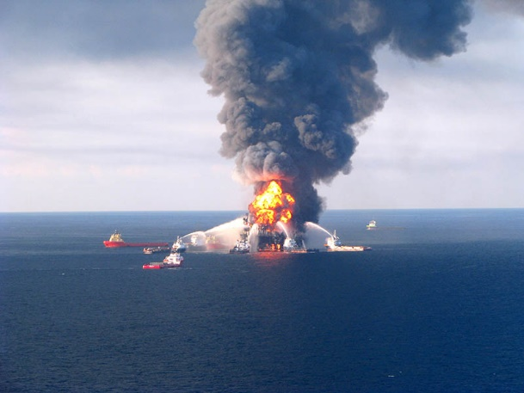

The Deepwater Horizon rig engulfed in flames ©CEDRE

On 29 April, the US Federal Government qualified the pollution as “national disaster”. On 30 April, following Louisiana, Alabama, Florida, and Mississippi declared a state of emergency. On 2 May, the US President Barack Obama arrived in Louisiana to oversee the response operations and to declare his solidarity towards fishermen and coastal populations. On 22 May, he announced the creation of an independent commission of inquiry tasked with finding the causes of the incident. On 14 and 15 May, Barack Obama visited the coast of the Gulf of Mexico for the fourth time.
The US government played an active role in the monitoring of actions organised by BP. The Department Of Energy asked scientists and engineers from various labs in New-Mexico and California for their expertise.
On 12 July 2010, the US Government introduced a 6-month moratorium (until 30 November) on deepwater drilling. It was to be lifted once a set of rules reinforcing safety measures on oil rigs had been established. The moratorium was lifted earlier than expected on 12 October.
In early August 2010, the scientists tasked by the US government with the evaluation of the amount of oil spilled by the leaking well announced their first estimate: 779,000 m3 of oil spilled, which represents 40 times the Erika spill, 20 times the Exxon Valdez spill or 3.5 times the Amoco Cadiz spill.
The operations on and under the water allowed the treatment of an estimated 40 % of the oil spilled: 20 % recovered, mostly by direct recovery at the well outlet (17 %) and only 3 % by skimming; 16 % by chemical dispersion (5 % on the surface, more than 10 % at the well outlet); 5 % by in-situ burning.
The leak was stopped in mid-July 2010 and the well definitively plugged on 19 September. About 36 % of the total volume of oil spilled was estimated to have been degraded (23 % by evaporation or dissolution, 13 % by natural dispersion).
On 1 December 2010, the administration froze the gas and oil exploitation in areas were no drilling was authorised (the central and meridional Atlantic coast, the west of the Gulf of Mexico), until 2017.
On 11 January 2011, initiated by President Barack Obama, the national commission tasked with the investigation on the causes of the explosion gave its findings in a report. It questioned the decisions taken by BP, Halliburton and Transocean (partners of BP), as well as the practices of the US oil rig control authorities.
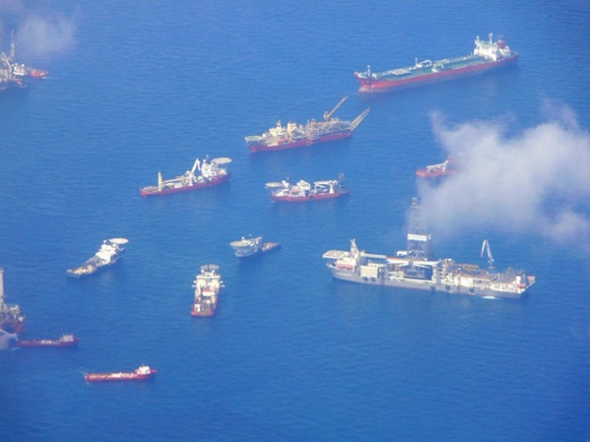
The explosion of the Deepwater Horizon drilling rig caused the largest oil spill in the history of the United States of America, maybe even globally if we only take into account the lower estimates for the spills caused by the Iraq/Kuwait conflict in the Persian Gulf in 1991 (500,000 tonnes). The response operations, regarding resources and expertise, on land in the air, on and under the water are incomparable with any other incident.

Flyover of the incident area ©TRANSPORTS CANADA
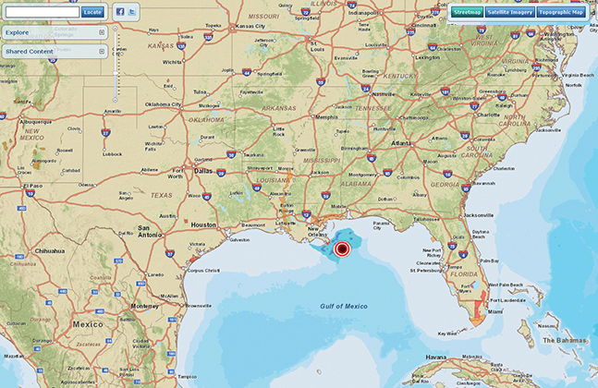

Collaborative map of the actions in the Gulf of Mexico ©ESRL

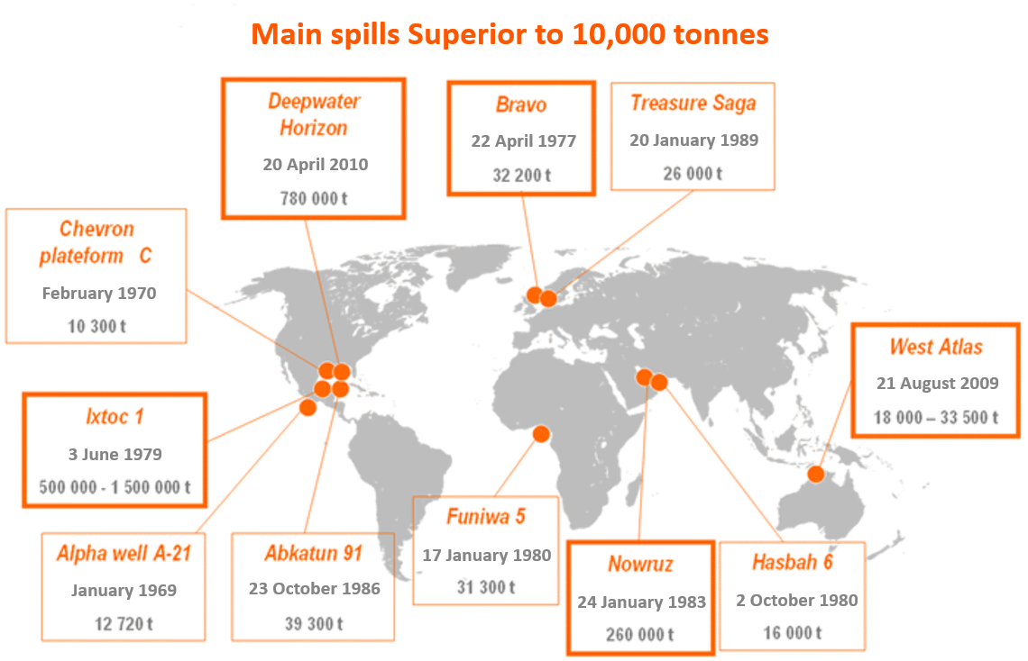
Main spills above 10,000 tonnes

The pollution
Behaviour of the pollutant
The oil spilled from the drill site was a light crude oil. The ADIOS model, designed to predict the behaviour of oils at sea, indicated that once spilled in the environment, this oil evaporated up to 35 %, diluted between 10 and 15 %, and the 50 % remaining emulsified up to 90 %.
Although it stayed really viscous, the oil could be recovered by pumping. It still required specific equipment such as adapted pumps and a water injection system to heat the pipes up.
Drifting of the slicks
On 23 April 2010, the oil spilled already formed a 1.6 km wide and 8 km long slick. Thirty-two vessels and five airplanes were mobilised to spread dispersant and launch skimmers. Still, the aerial survey from 25 April 2010 showed sheen spreading on 32 km² and contained emulsified crude oil. Two days later, this slick was only 37 km off the coast of Louisiana.
On 28 April 2010, the winds changed direction and pushed the slicks towards the coast, which represents a particularly sensitive ecological and economical area. On 29 April, the first signs of pollution showed in marshes close to the Mississippi estuary. On 1 May, the size of the slick was evaluated to 1,500 km², about the size of a city like London.
Pushed by winds and currents, the oil slicks moved at sea. In late May – early June 2010, part of the slick in the south was caught by the “Loop Current” and the pollution was feared to exit the Gulf of Mexico. The alert was however short-lived.
On the coastline, pollution spread to various degrees, from East Texas to West Florida.
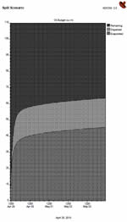

ADIOS model prediction for the behaviour of the pollutant ©USA TODAY

The role of natural elements
The eddies formed by the currents in the incident area, mainly due to the “loop current”, were really useful in avoiding a spread of the pollution. These eddies trapped the oil in their center, where it weathered, fragmented, and naturally degraded. This phenomenon helped avoid the spread of significant amounts of oil to the West coast of Florida.
The semi-closed Barataria Bay was the only area where currents were unfavourable and suffered severe pollution on some sites.
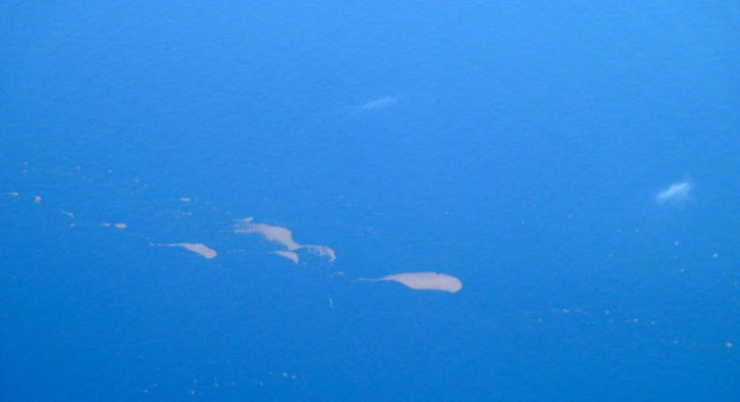

Slick of emulsified crude oil ©CEDRE

Organisation of the response
Very soon after the accident, the US administration and BP set up a solid command system. Response organisation was coordinated as follows.
On 1 May, the National Incident Command (NIC) – the hierarchised command structure assembling and coordinating all public (federal, state, local, and tribal) and private resources such as BP and other stakeholders from the platforms – was implemented. The NIC was supervised by the Unified Area Command (UAC).
Based in New Orleans, the UAC coordinated 4 Incident Command Posts (ICPs): for Texas in Galveston, for Louisiana in Houma – in charge of response operations at sea and on the shores of Louisiana – , for Alabama in Mobile – in charge of shoreline response in the States of Mississippi, Alabama and the Florida Panhandle – , and for Florida in Miami. The ICP in Houma was the largest, comprising 1,200 people and operating 24/7.
Members of the command centre included: twenty-odd federal agencies (USCG, NOAA, EPA,…), the State Government, parish and tribal Governments, as well as NGOs, various consultants and BP (responsible parties).
A fifth centre, the Source Control Command (SCC), based in Houston, Texas, was specifically dedicated to response to the leaking well.
Under the orders of the ICPs, Forward Operative Bases (FOB) were in charge of implementing response operations (at sea, in coastal waters and on the shoreline).
At the heart of the response interventions, in early June, 47,000 responders were involved on land and at sea.
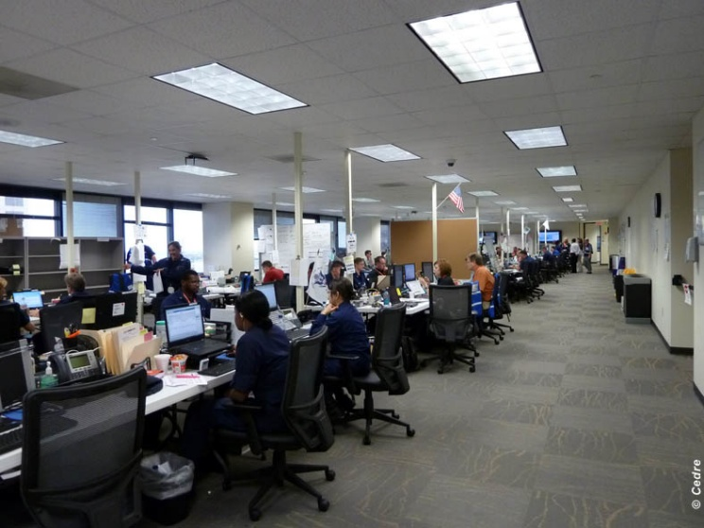

UAC of New-Orleans ©CEDRE

Response at sea
The main strategy of the American teams consisted in preventing the oil from reaching the coasts, namely the coasts of Louisiana.
To do so, aside from the recovery of oil at sea, two other techniques are employed: the usual dispersion and in-situ burning, a much less used method, particularly at this scale.
Recovery
The deployment of a sizeable naval armada is part of the frequent superlatives used to describe this pollution. During the first half of June, more than 6,000 ships, barges, and skimmers were mobilised, including a barge dedicated to the deployment of more than 750 skimmers of all kinds.
An important flotilla of fishing boats was mobilised. The employment of fishermen by BP partly compensated their loss of activity. They acted as support during containment and skimming operations, as well as dredging using sorbent booms.
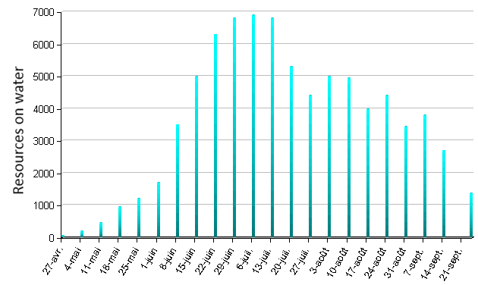

Evolution of the response resources on water ©CEDRE

Early July 2010, the 355 m-long super tanker A Whale, adapted by a charterer from Taiwan, operated recovery tests at sea. It was able to pump a mixture of oil and water, then separated both, transferred the oil on another vessel and the water back at sea. After an inconclusive testing phase, BP did not choose this vessel to integrate its response system.
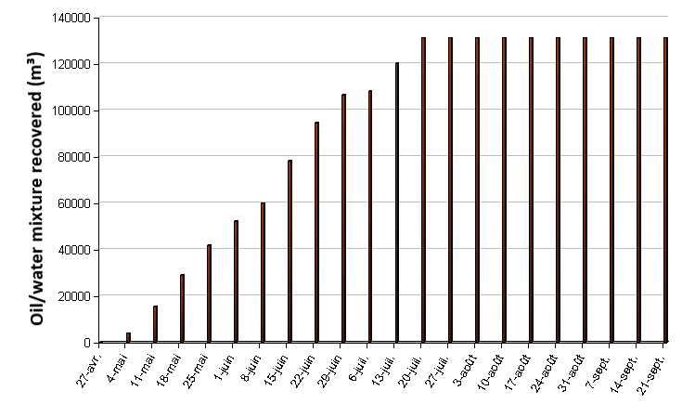

Amount of the water-oil mixture recovered at sea ©DEEPWATER HORIZON RESPONSE

At the end of July, the American teams announced the recovery of 131,000 m³ of water-oil mixture but without announcing the proportions of this mixture.
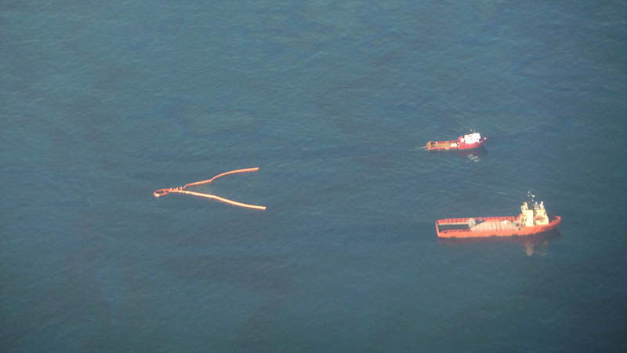

Recovery by dredging ©CEDRE

Dispersion
This was the first time such a high amount of dispersant was used. It is important to note that, in the history of modern pollution, such favourable conditions were never seen before. They included a continuous release of crude oil at a depth favouring an important dissemination of the dispersed oil.
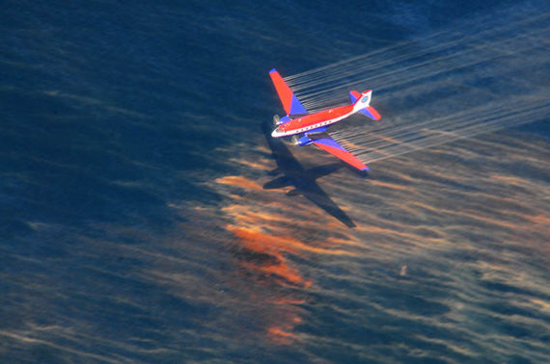

Aerial spread of dispersant ©USCG PHOTO

This treatment was operated mainly by plane close to oil surfacing areas. On 15 July 2010, the volume of dispersant spread on the surface of water by planes reached 4,000 m³.
To use the water column (1,500 m) at best and disperse the oil before it surfaced, the American teams innovated by injecting more than 3,000 m³ of dispersant at the well outlet. In parallel, an important oil measurement system in the mass of water was implemented to evaluate the effects of this technique in the environment.
In total, 16 % of the oiled spilled was chemically dispersed.
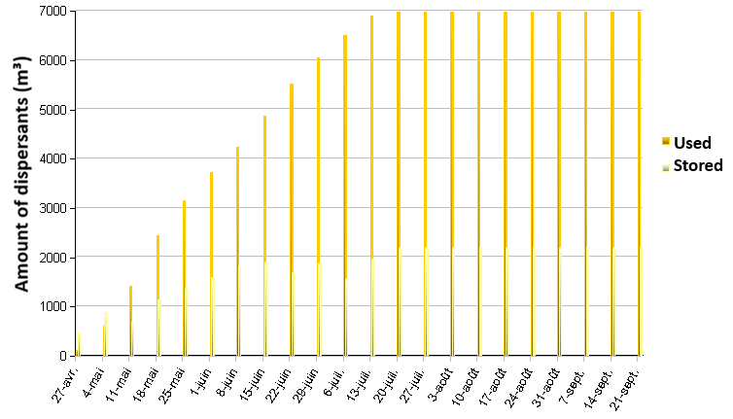

Evolution of the amount of dispersant (in m³) ©DEEPWATER HORIZON RESPONSE

In-situ burning
On 28 April 2010, in-situ burning tests coupled with containment of oil slicks using herders were carried out. Due to the strong winds in the area, the test could not be carried out the following days.
On 5 and 6 May, as well as on 17,18, and 19 May, favourable meteorological conditions allowed for the in-situ burning operations of parts of the slick to resume.
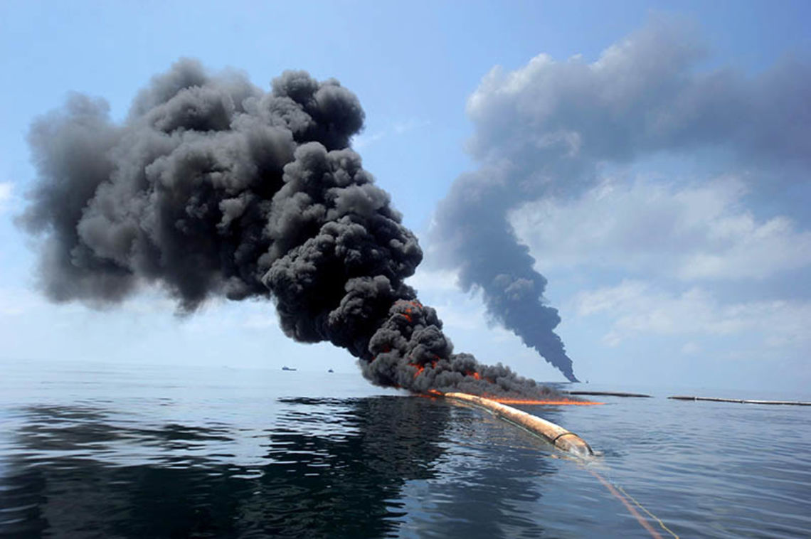

In-situ burning operations ©USCG PHOTO

The static and punctual burning technique was replaced by dynamic burning. It consisted in progressively concentrating the oil to keep feeding the fire using a herder towed by two vessels in pair-trawling. The operation was carried out by trained fishermen but the technique remained dangerous.
At the end of July, 411 controlled burning operations were carried out to disperse more than 42,000 m³ of oil in the atmosphere. Observations showed that the combustion residue sank rapidly.

Operations on the well
First tries
In parallel to pollution response on the surface, response is quickly organised to resolve the situation at the source.
For days, ROVs attempted to close the well’s BOP (Blow Out Preventer), which should have closed by itself and plugged the well outlet in the event of excessive pressure. On 5 May 2010, BP announced that they were able to plug three leaks by installing a valve on the breach with ROVs. Multiple tries followed using various techniques to try and plug the leaking well definitely.

Containment at the source
Sarcophagus containment
BP tried to stop the leak by containing it inside a 98 tonnes metal sarcophagus. The containment chamber was deployed on the evening of 5 May 2010 to be transported to the leaking well by a drillship, the Discoverer Enterprise. It arrived on site the next morning and was placed on the ocean floor to encapsulated the main leak situated 1,500 m below the surface and recover 80 % of the oil spilling from the reservoir.
The attempt started on 7 May was aborted the next day as methane clathrate crystals accumulated in the containment chamber and prevented the pumping of the oil to the surface. The sarcophagus was removed the following day and left on the ocean floor, 500 m away from the leak.

Flexible pipe on the riser
In the night from 16 to 17 May 20210, a flexible pipe was successfully inserted on the riser (at the end of the pipe) that connected the well and the Deepwater Horizon platform that was now at the bottom of the ocean. This successful operation helped recover part of the oil and gas before they escaped in the water column. Methanol was injected to avoid the apparition of methane clathrate. The oil was then transferred daily to the surface from the 17 to the 25 May, on the drillship Discoverer Enterprise. Water and oil were then separated on its board: gas was burned on site, water was rejected in the ocean, and oil was recovered. The daily average regarding oil recovery was around 320 m³. With the approval of the government, this technique was abandoned on 25 May.
New containment chamber
On 3 June, a new containment chamber (Lower Marine Riser Package Cap Containment System), smaller than the first one, was set up. It had to recover more crude oil than the flexible pipe system did. To do so, the damaged portion of the riser was cut at the well outlet. The containment chamber was connected to a rising pipe, guiding the oil and gas to the Discoverer Enterprise drillship on the surface. This method helped catch most of the flow of oil and gas from the well without risking the formation of methane clathrate crystals due to the injection of methanol. The daily average regarding oil recovery was around 2,400 m³.

New riser
A second riser was added to this system on 16 June 2010 to link the well to the multi-task vessel Q4000 on board of which part of the oil and gas was burned.
On 22 June 2010, a third crude oil storage vessel, the Helix Producer, was being prepared to be deployed on site. The American government forced BP to find solutions to improve the oil recovery capacities. The goal was a daily recovery rate between 6,360 and 8430 m³ by the end of June and between 9,540 and 12,720 m³ by mid-July.
After the Helix Producer arrived on site on the 30 June 2010, BP teams started the procedure to link the containment chamber to a floating riser. The operation was completed on 11 July 2010.
For safety reasons, the recovery and in-situ burning operations were stopped on 1 July due to strong swell from the cyclone Alex. They resumed on 4 July 2010.
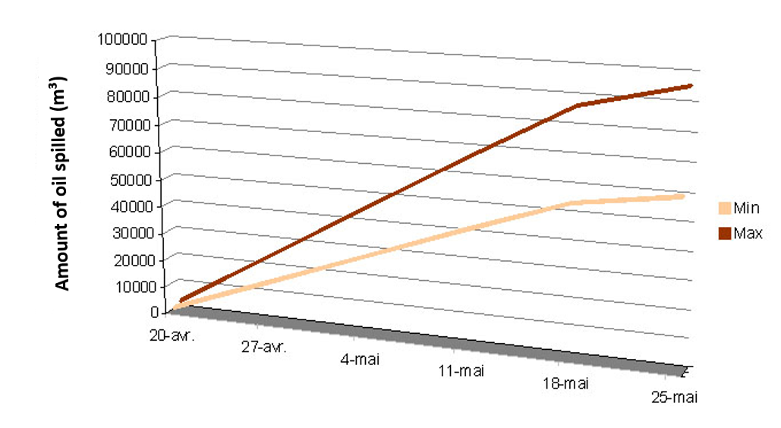
Estimates of the amount of crude oil spilled at sea ©DEEPWATER HORIZON RESPONSE

Top Hat 10
On 10 July 2010, a new funnel called the Top Hat 10 was fitted on the well outlet. This new system allowed the progressive closing of the valves to completely stop the leak. It was closely monitored (seismic and acoustic studies) to detect eventual anomalies. Frequent pressure measures were also taken.
As soon as the system was in place, these measures indicated a lower pressure than what was expected. Two reasons could explain this phenomenon: either the oil reservoir was close to empty, or there was an eventual leak.
Additional studies were carried out to try and explain this low pressure that nevertheless kept on rising.
In late July 2010, the tropical depression Bonnie passed through the Gulf of Mexico. Operations were called off on 23 July 2010, but resumed the following day, only slightly delaying the progress of operations.

Methods to “kill” the well
Top Kill and Junk Shot
After multiple fails, BP considered two new methods to top the endless oil spill directly at the well outlet:
“Top Kill” consisted in injecting heavy drill fluids in the well;
“Junk Shot” consisted in projecting various debris, such as tire parts, in the well.
The Top Kill operation, carried out with high expectations on 27 and 28 May 2010, failed on 29 May because the flow of oil was too important.

Static Kill and Bottom Kill
On 3 August 2010, the Static Kill operation was launched. It aimed to pump drilling mud and cement into the main well (a similar technique to Top Kill). On 5 August, the US authorities and BP announced that the Static Kill operation had been a success.
A second technique, dubbed Bottom Kill, was implemented on 14 August 2010. It consisted in pumping cement, but this time via the relief wells, so as to definitively seal the well. On 19 September, the operation was a success and the well was plugged.

Drilling relief wells
Two platforms, named Development Drill III and Development Drill II, arrived onsite respectively on 2 May and 16 May to drill two relief wells intended to join the main well, to inject a filler to definitively kill the well. An electric signal is regularly sent into each relief well to determine the remaining distance to be drilled before reaching the main well.
On 9 August 2010, the well drilled by Development Drill III reached a depth of about 5,458 m under the seabed, the one drilled by Development Drill II reached about 4,865 m.
On 4 September, the faulty blow-out preventer (BOP) was replaced. On 17 September 2010, the relief well drilled by Development Drill III intercepted the leaking well. On 19 September, the well was definitively plugged by pumping cement into it.
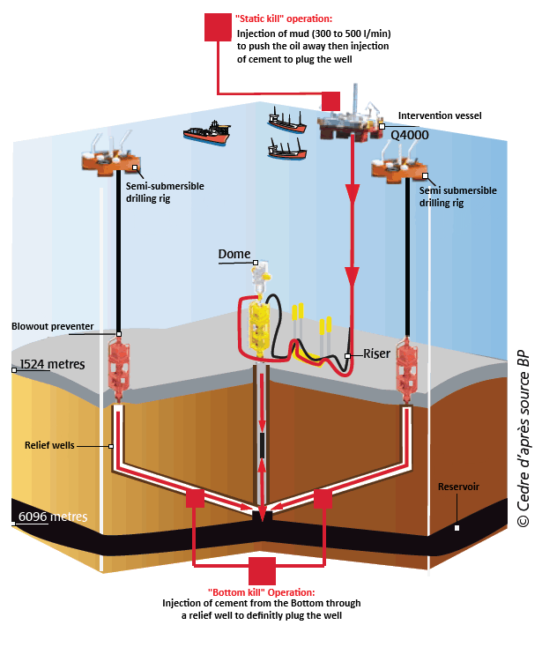

Well plugging system ©CEDRE
© CEDRE adapted from BP

Response on land
Massive use of booms
The American authorities mainly used booms to protect the coastline. More than 3,700 km of booms were deployed during the crisis: 1,200 km of floating booms and 2,500 km of sorbent socks. Part of these booms were regularly destroyed by the wind. For a better resistance to wind and currents in some areas between the islands of Louisiana, as well as to prevent the oil from reaching highly sensitive marshes, a custom, impressive system was deployed. Dubbed the Rigid Tube Boom, it consisted in assembling multiple kilometres of metal pipes with skirts and positioning them between rows of metal spikes planted in the mud using a crane pontoon. This system was installed to block sensitive areas in Alabama and on 3 km off marshes in Louisiana.

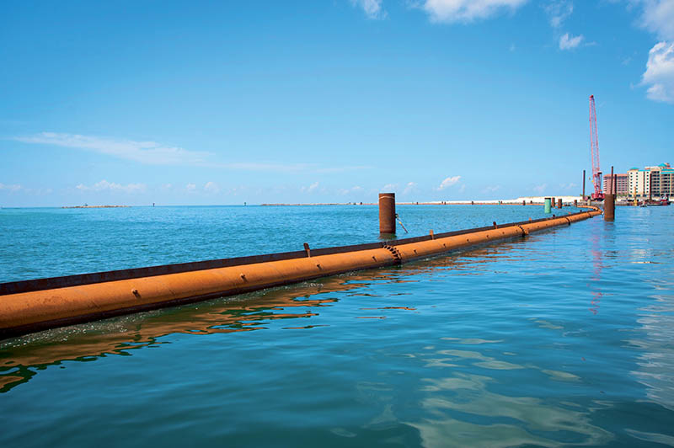

Rigid Tube Boom: floating booms fixed to spikes ©USCG PHOTO

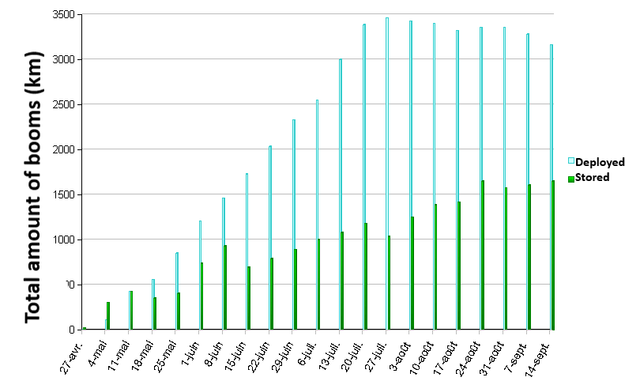
Evolution of the amount of booms (in km) ©DEEPWATER HORIZON RESPONSE
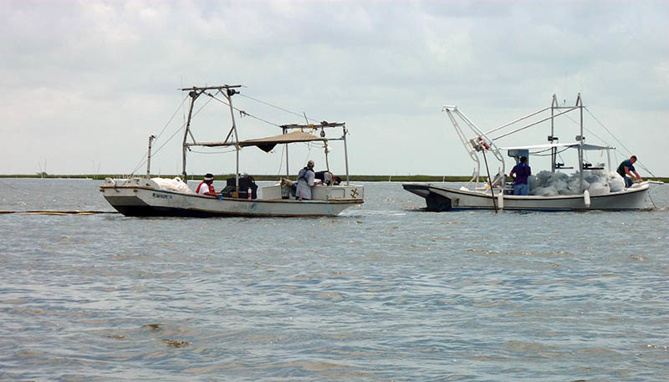

Transportation of sorbent booms ©CEDRE

Use of response methods against erosion on the coastline
This consisted mainly in geotextile fabric socks filled with a mixture of sand and cement, as well as Tiger Boom, a long double pocket resembling shore-sealing booms but filled with sand. Both systems were place parallel along the beach and doubled with sand barricades.
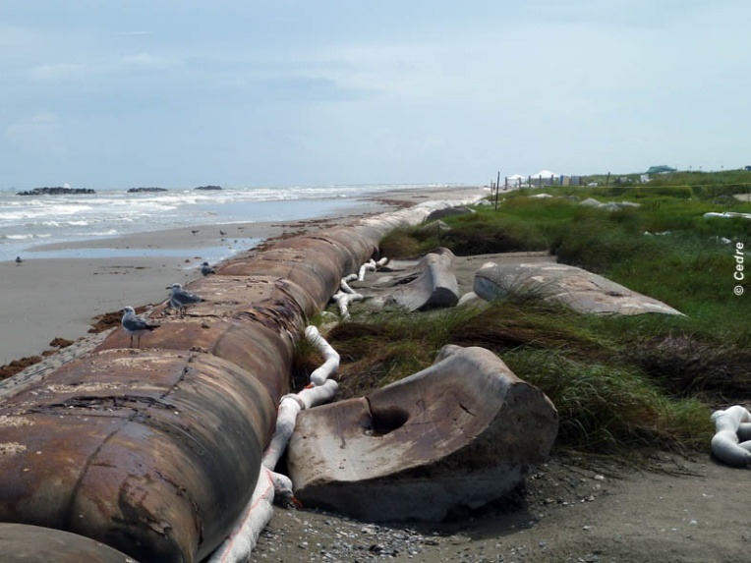

Anti-erosion system and sorbent booms ©CEDRE
Cleaning techniques
Manual and mechanical collection of stranded oil using screening machines was completed with sand cleaning machines. This technique consisted in cleaning the sand with hot water (without products) to remobilise the oil on the surface, and then centrifuge the mixture to collect “wrung” sand.
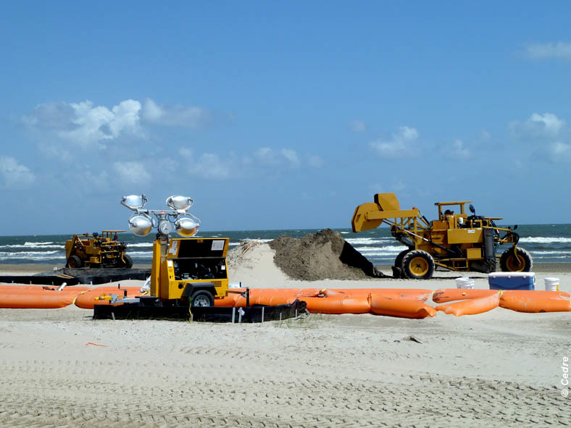

Sand pile for cleaning ©CEDRE
Use of a new system: creation of sand barriers to trap the pollutant
On 27 May 2010, the commandant of the response operations gave the GO for the implementation of a sand barrier, the Sand Berm Barrier, on each side of the Mississippi delta in Louisiana, on a reduced distance compared to the one originally planned (16 km instead of 206 km). The sand was collected by dredging, far from the barriers to avoid digging in the foreshore, in some identified accumulation sectors (under the surface, offshore, and in the Mississippi riverbed), from where it was transported by barges to be dropped on the coastline using pumps. It formed a frontal levy protecting the islands with a water depth of 1.80 m.
The cost of operation reached $220 million funded in part by BP.
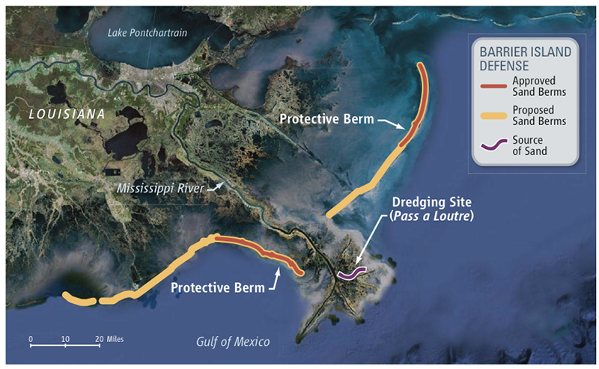

Project for the creation of sand barriers ©USC

Human resources deployed
Dozens of technical evaluation teams (Shoreline Cleanup Assessment Team - SCAT) surveyed the coastline: all of the information sent to the command centres helped each state assess their situation, define methods and priorities regarding cleaning operations.
Troops of manual cleaners walked the beaches daily to collect pollutant clumps: mostly plaques and balls, sometimes micro balls.
Due to the hot weather, tents were set up every 500 metres on the beaches of Louisiana to help the operators rest at regular intervals.

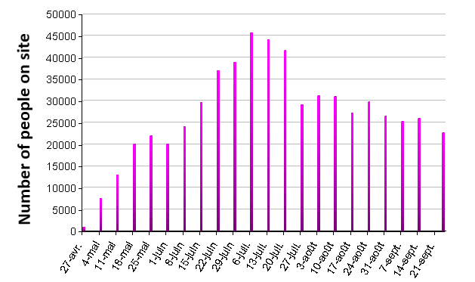
Evolution of the amount of operators mobilised on site ©DEEPWATER HORIZON RESPONSE

Training of the operators
Training was organised by the Department of Labor's Occupational Safety and Health Administration (OSHA) for operators employed by BP and tasked with shore cleaning and sea response.
OSHA is part of the US Department of Labor, its mission is to ensure the safety of workers. This agency distributed thousands of safety guides and information bulletins to everyone (volunteers included) involved in shore cleaning and sea response. These documents were written by OSHA in collaboration with the National Institute of Environmental Health Sciences(NIEHS), one of the institutes of the Department of Health et Human Services (HHS).

General information on response at sea and shoreline protection
Dispersion
Mode of operation
Dispersants are products that accelerate the natural dispersion of oil by the swell, which makes the dissociation of surface slicks into a multitude of droplets in the water column easier. Dispersants have two advantages. The first one is the dispersion of surface slicks in the water so they are no longer influenced by the wind, which is important when said wind blows in the direction of ecologically sensitive areas. The second one is the separation of the slick into a multitude of droplets, which makes the degradation of the oil by bacteria in the water easier.

Limitations
However, the use of dispersants is technically limited. They need to be used in precise rates and conditions. They are not really effective on viscous or weathered oils. The decision to use them in a particular setting must be taken quickly: dispersion is only an option in the first hours or days, it needs to be part of the contingency planning according to the characteristics of the area. Most the the plannings differentiate areas for the free use of dispersants, areas of conditioned use, and areas in which the use of dispersants is prohibited.
Toxicity
The dispersants still have a negative image. They were accused of being more toxic than the oil and of moving pollution by “sinking” the oil to the floor bed where it acted as a death layer. These last accusations are unfounded: dispersants fraction the oil into a multitude of droplets which spread in the water, they do not sink to the bottom. The dispersion of oils leads to a local, temporary increase in toxicity, only until the dispersed oil disseminates in a large water volume and becomes inoffensive. This implies a certain limitation for the use of dispersants near the coasts and in sensitive areas and/or when dilution conditions are diminished. Modern dispersants, concentrated and validated, are generally less toxic than the dispersed oil.

Testing
Dispersants are subjected, in some countries, to testing procedures regarding their effectiveness, toxicity, and biodegradability potential. The control process for a new product starts with an effectiveness test, with the result influencing the testing conditions for the other criteria. In France, these tests are carried out by CEDRE since 1978. The test results for a product are valid for a period of 5 years.

In-situ burning
In-situ burning is a solution for the reduction of the amount of oil susceptible of polluting the waters. It can happen naturally, when the incident results from an explosion, or when a spark created a fire during the spill. The intervention then consists in controlling the fire without extinguishing it. However, deliberate fires were occasionally started, on the vessel itself (Torrey Canyon in 1967) or on confined slicks within herders (Exxon Valdez in 1989).
Voluntary in-situ burning still stays an exceptional measure. It is technically only applicable on fresh oil before evaporation of volatile elements and in very specific conditions. Heat, combustion gas, and soot constitute other forms of pollution, they are drawbacks to the decision of creating such fires.
This response method is not authorised in France.

Protection measures on land
When the circumstances and the time frames allow it, some measures must be taken before the pollution reaches the shores, in order to make the cleaning operations on the shoreline easier and to limit the impact of the pollution.
The collection of macrolitter and natural strandings before the pollution reaches the shore helps limit the volumes of oiled material and facilitate the cleaning operations. Depending on the scale of the strandings, this cleaning is either carried out manually or done using public construction machinery or specialised equipment such as screening machines. It must also be as selective and specific as possible.
The global protection of bays, estuaries or abers using floating booms is generally useless due to the strong currents that flow in these areas. Some more restricted areas can still be protected.
Using filtration booms to protect various canals, water inlets used for aquaculture, salt marshes, thalassotherapy centres and other installations requiring salt-water should also be considered. The usable resources vary depending on the area of the site that requires protection: the main ones include straight nets, filtration barriers, or dams made of mud and various materials. Some of these protections combine the retention function of the dam with a fixation of the oil on a sorbent. The response equipment distributors offer sorbent booms which are adapted to relatively low amounts of fluid pollutant or pollutant that has been thinly divided. A net filled with straw can be a solution, provided that the straw is changed often enough and properly disposed of once oiled.
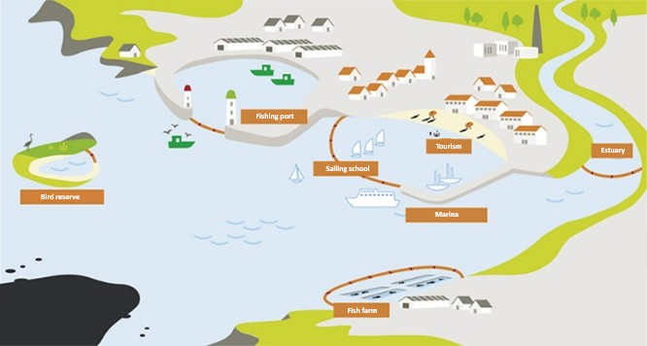
Protection of sensitive areas ©CEDRE

Effects of the pollution
Ban on fishing
On 2 May, fishing was banned in the federal waters affected by the spill. BP then contracted the fishermen to take part in spill response. On 7 May, fishing was banned in less than 4.5 % of US waters in the Gulf of Mexico. At the end of May, 20 %, and at the end of June approximately 36 % of federal waters of the Gulf of Mexico were closed to fishing.
On 22 July 2010, about a third of the banned fishing area was reopened. The reopening concerned the Florida platform, South-East of the drilling rig, according to a NOAA validated protocolThe US Food and Drug Administration (FDA), as well as the states along the Gulf of Mexico. Three main criteria are taken into account:
- No trace of oil must be observed for 30 days;
- The fish meat samples must show no taste or smell of oil;
- The analysis carried out on said meat must show a chemical substance level below the upper threshold.
The area closed to fishing was reduced to 24 % of federal waters.
On 10 August, an area of 13,323 km² was reopened only for fishing, 22 % of the Gulf waters remained closed.
The closed area was progressively reduced to 2,700 km2 on 2 February 2011, about 0.4 % of the federal waters in the Gulf of Mexico. However, on 24 November, NOAA closed 10,900 km² to royal red shrimping after a fisherman discovered tar balls in his net. This ban was lifted on 2 February 2011.

Census of marine life in the Gulf of Mexico
The results of an international study (Census of Marine Life), conducted over 10 years, on the distribution of species and their diversity in the world's oceans, and in particular in American waters, (An overview of Marine Biodiversity in United States Waters), was published on 2 August 2010. The census covered 15,419 species (plants, animals and microbes) in the Gulf of Mexico before the oil spill, which will enable the impact of the disaster to be more accurately assessed.

Rapid response venture
On 21 July 2010, four oil companies (ExxonMobil, Chevron, ConocoPhillips, Shell) created a company with a one billion dollar fund, the Marine Well Containment Company (MWCC), to create a standard intervention system for a well 3,000 m deep with the goal to absorb an major oil or gas leak in the Gulf of Mexico. This system would be operational within 24 hours and would be functional in all weather conditions. On 20 September, BP announced its intent to join the Marine Well Containment Company (MWCC) to share the experience acquired through this accident. BP also wanted to make available to any company operating in the Gulf of Mexico the response equipment used.
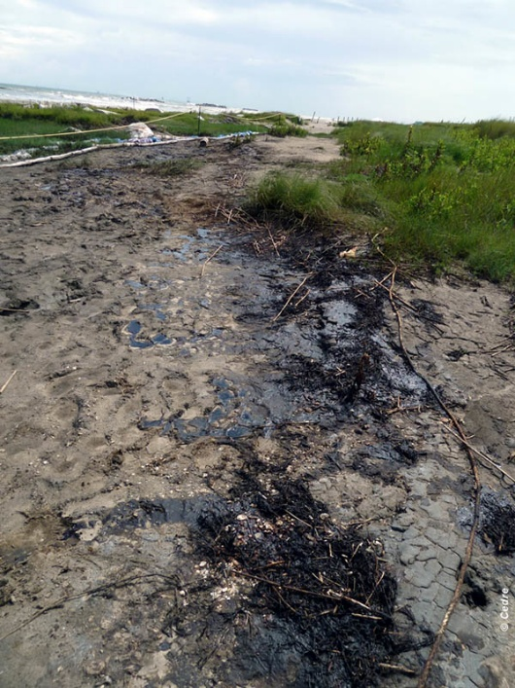

Port Fourchon, July 2010 ©CEDRE

Biological impacts
In June 2010, the US Fish and Wildlife Service (FWS), tasked with the management of wild flora and fauna, deployed 600 people on site to coordinate the research, collection, and cleaning of birds, marine mammals and reptiles (including marine turtles).
The FWS also announced, on 28 June, the implementation of a large scale safeguarding plan for turtles. Its goal was the collection of tens of thousands of turtle eggs from threatened species (Loggerhead, Kemp’s rideley, leather back, and green sea turtles) on beaches of Alabama and the North-West of Florida. They would then transport these eggs individually in polystyrene boxes, by plane, on a clean shore on the East coast of Florida. When they hatched, the babies would be helped by hand to reach the ocean.
Despite the strong uncertainty regarding the results of such a plan, the FWS considered that inaction would lead to a loss of all the newborns north of the Gulf. At the end of August 2010, this operation is considered to be a success as 15,000 turtles were able to reach the sea.

The UAC (Unified Area Command) located in Louisiana centralised data on the recovery of stranded specimens. Between the start of the oil spill and the end of January 2011, the impact on fauna is as follows:
 | Dead | Not impacted by visible oil
Birds | 6,124 | 54 %
Marine turtles | 608 | 52 %
Marine mammals | 100 | 96 %

Impacts on the health of the responders
Particular care was given to the health of the responders operating on land and at sea.
They were encouraged to declare any symptoms or sickness to BP’s health services. This data was then transmitted to OSHA and NIOSH (National Institute for Occupational Safety and Health), the latter being part of the HHS (US Department of Health and Human Services) and having as a mission the conduction of research and the formulation of advice on work related health issues.
Reports on the most common pathologies depending on the geographical situation of the workers were regularly produced and updated. The phenomenon of heat strokes was also monitored due to the hot weather and high humidity level in the Gulf of Mexico. The heat sensation was also increased by the protection equipment worn by the responders.

Compensation for environmental damages: the Natural Resource Damage Assessment (NRDA)
After an oil spill on the scale of that of the Gulf of Mexico, an institutional procedure, known as NRDA, is implemented by NOAA, to compensate and restore environmental damage. The parties responsible for the spill are involved in this procedure and are responsible for the costs of restoration and implementation of the NRDA process.
In the case of Deepwater Horizon, the first stage in the NRDA procedure (pre-assessment stage) was implemented at the very beginning of the pollution. This procedure is piloted by NOAA through its Damage Assessment, Remediation, and Restoration Program (DARRP). It involves collecting data from the edge of the pollution on the biological state of many categories of resources (birds, marine mammals, subtidal and intertidal habitats). Data is also collected on the recreational activities liable to be impacted by the pollution. In mid-September 2010, around 3,200 km of coastline was studied and 23,500 samples were taken. In January 2011, the numbers on sampling were as follows: 13,677 samples of water, 6,010 samples of biological tissue, 4,506 samples of sediment, 1,917 samples of tar balls, 783 samples of soil. 295 NOAA staff and 475 contractors are employed in the NRDA effort. The parties responsible for the accident had already paid out over 45 million dollars to conduct the first stage of the NRDA.
The first stage in the NRDA procedure was completed in mid-September 2010 and the damage assessment and restoration planning stage was launched. This phase will last from several months to a number of years.

Monitoring of the pollution
By the authorities
Regular controls of the air quality on the American coastline of the Gulf of Mexico were carried out and are available on the EPA's website, where they are archived.
In parallel, the EPA provides the results from the monitoring carried out for air, water, sediments, and dispersants.
The movement of the slick is monitored through the analysis of satellite pictures and aerial surveillance.
From the beginning of May to mid-July 2010, the Canadian National Aerial Surveillance Programme(NASP) carried out 298 hours of flight during 63 surveillance missions. The monitoring operations were later carried out by an Icelandic team.

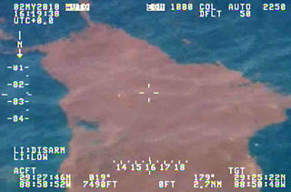

Aerial monitoring of a slick at sea, May 2010 ©TRANSPORTS CANADA

Drifting models were edited twice a day by NOAA.
On 15 May 2010, a monitoring system was implemented by the Everglades National Park to alert on any aquatic contamination.
A team from the "Mussel Watch" programme of NOAA was sent to the Gulf of Mexico to collect samples of mussels, oysters, water, and sediment. This national scale programme has been in place since 1986 to carry out a continuous monitoring of American coastal waters.
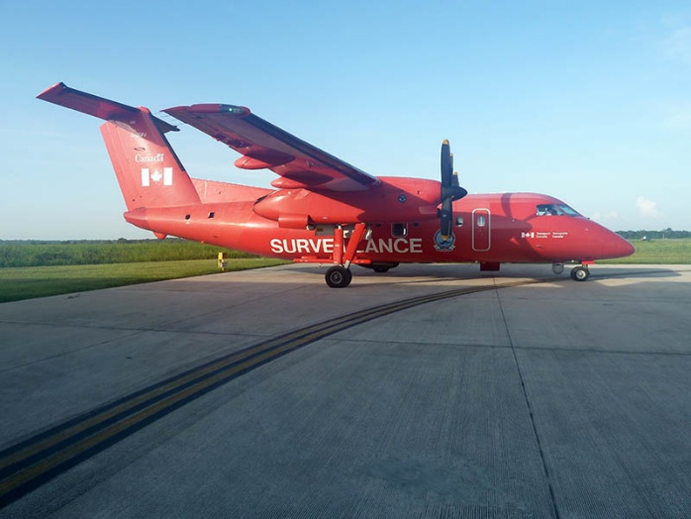

Dash 8 – 200 Canadian ©TRANSPORTS CANADA
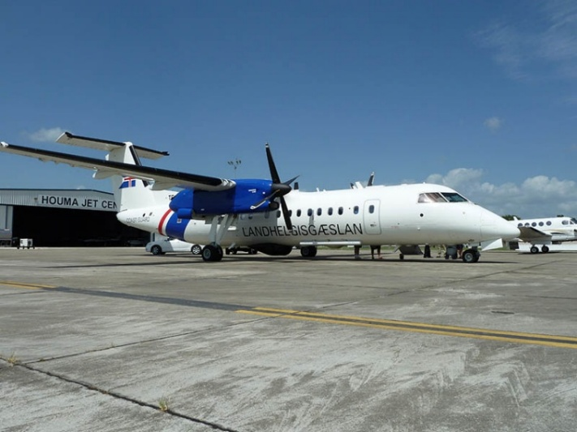

Dash 8 – 300 Icelandic ©TRANSPORTS CANADA

By scientific institutions and universities
An ocean mission initially dedicated to the study of corals in deep waters was reoriented to collect water and sediment samples in areas close to oil leaks. These samples should help determine the reference state of the ecosystem to measure changes that might happen in these places after an oil spill.
As for pollution response, the Deepwater Horizon incident led to exceptionally numerous impact evaluation actions: the incident was followed by countless studies, funded as part of various programmes, private and public initiatives, for a relatively long period of time (the BP fund for example, amounting to $500 million on 10 years, destined for the funding of long-term research: the Gulf of Mexico Research Initiative (GoMRI)). Website reserved for the diffusion of results: www.gulfresearchinitiative.org/). It aims to answer various interrogations.
In August 2010, although American experts agree on the amount of oil that leaked from the well (4.9 million barrels = 779,000 m3), there are still differences between the report from the National Incident Command (NIC) and the study from the Georgia Sea Grant Program (published in 2010 by C. Hopkinson with as title: Outcome/Guidance from Georgia Sea Grant Program: Current Status of the BP Oil Spill) regarding the repartition of the various oil fractions (evaporated, dispersed, burned, biodegraded…) and therefore on the amount of oil remaining in the Gulf of Mexico.
On 19 August 2010, a team from Woods Hole Oceanographic Institution (WHOI) announced, in a paper published in Science magazine, the detection of a plume of micro-droplets of oil. It is reported to be 35 km long by 2 km wide, and 200 m high, and lingering 1,000 m below the surface of the ocean.
In an article published on 6 January 2011 in the Science magazine, scientists from universities in Texas, California, and New Hampshire showed that all of the methane, dropped back into the water after the incident, disappeared by September. According to these authors, this disappearance was due to blooms of “methane eating” bacteria.

International aspects
In the first weeks of the pollution, BP, through two OSROs, (Oil Spill Response Organizations), tried to assess the expertise and response resources available at a global scale.
Multiple countries also rapidly offered their help and resources voluntarily.

Europe
After initially declining offers, the American authorities look for, through the diplomatic way of the IMO or through the civil protection unit of the European Commission:
- Early May 2010, dispersants and booms,
- Early June herders and mid-size booms,
- Mid-June, High-capacity skimmers.
In Europe, EMSA, Belgium, Croatia, Denmark, France, Germany, Greece, Ireland, the Netherlands, Norway, Portugal, Romania, Spain, Sweden, and the United-Kingdom therefore offer various pieces of equipment and products that were partly accepted to reinforce the impressive response arsenal deployed by the American authorities.
On 13 October 2010, the European Commissioner for Energy presented a legislative proposal on oil rigs, which would impose the strictest safety standards in the world. This proposal takes the best practices existing in Europe and enforces them as standard throughout the European Union. It planned for more strict criteria to obtain a drilling permit. This project, presented in October 2011 to the European Parliament and Council, was not adopted and was deemed “unacceptable”. Three years later, on 21 February 2013, the Member States and MEPs agreed on a directive on safety of offshore oil and gas operations at sea: the member states must ensure the oil and gas companies that ask for a new drilling permit respect particular demands (to integrate the national law of each member state in the following couple of years). These requirements concern companies that must provide and emergency contingency plan and sufficient financial guarantees to reimburse damage to the environment in the event of an incident.

France
Several French service providers and response equipment manufacturers became involved in this response.
In June 2010, the sale of several Cataglop recovery barges and the lease of the recovery vessel Catamar to the Florida-based company AshBritt by the Briton company Ecocéane were splashed across the press.
The efficiency of a recovery net named the Nymphea Oil Trawler Instant Launch, or NOTIL, proposed by the company Nymphea environment, affiliate of the Vinci group (Bouches du Rhône) was under assessment in late July 2010.

CEDRE
At the request of the government in the Bahamas, the IMO sent two experts in Nassau in early June 2010 to evaluate the risks of pollution in the event of a drifting of the slicks outside of the Gulf of Mexico.
CEDRE's Caribbean delegate and an expert from the regional RAC/REMPEITC centre in Curaçao were sent on site to assess the Government's level of preparedness to respond to potential pollution, focusing on its national spill contingency plan and the Government and oil industry means available in the Bahamas. Recommendations were given regarding monitoring and protection of the islands west of the Bahamas, which were the most at risk for pollution.
Mid-July 2010, an expert from CEDRE participated in an international mission involving fifteen people from international organisations (OMI, EMSA, IOPC Funds…) and delegates from various States (South Korea, New-Zealand…).
At the same time, CEDRE’s director was invited by BP to assess the situation. This mission led to a visit of the command centre in Houma, set up in one of BP’s training centres and to a SCAT survey mission. A meeting with the Consulate General of France in New Orleans was also organised.
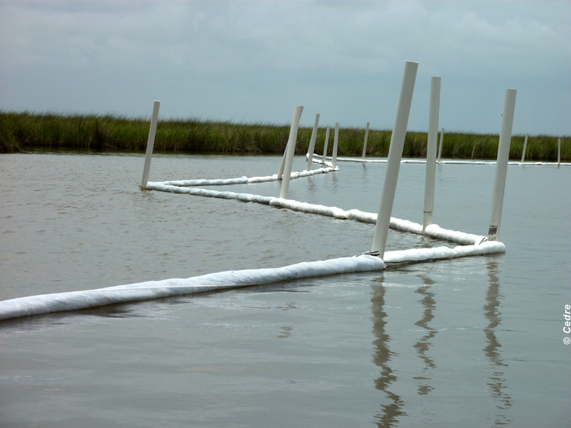

Deployment of sorbent booms ©CEDRE

Financial compensation
Multiple responsibilities
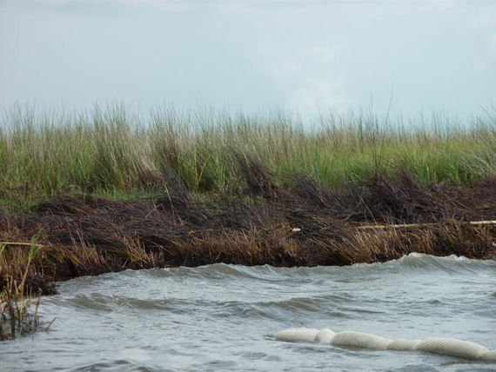

Polluted coastline ©CEDRE

From the beginning, BP announced it would take full responsibility for managing the oil spill and clean-up. It agreed to compensate the “legitimate” victims of the oil spill. According to analysts Sanford Bernstein & Co in New York, this cost BP over 8 billion dollars.
However, regarding the incident on the Deepwater Horizon, the blame was harder to place. Indeed, BP held only 65 % of the shares on the oil reservoir in the Gulf of Mexico. The rest was owned by the Canadian Anadarko Petroleum Corp. (25 %) and by the Japanese company Mitsui & Co (10 %). Moreover, the rig was owned by Transocean, a Swiss drilling company based in Houston (US). Other companies involved in the oil industry could also be involved, namely Cameron International and Hydroil, which provided the blowout preventers.

Towards a future increase of compensations?
In 2011 in the US, the economic damage due to incidents were compensated up to 75 million dollars by oil companies. A number of senators, estimating that this amount was not high enough, proposed a bill to increase the maximum to 10 billion dollars.
Additionally, once this maximum was reached, the victims (companies or individuals) could ask for compensation under a special fund coming from a tax on oil imported or exported by the US. However, the total amount could not exceed a billion dollars. Senators therefore proposed to also increase this limit.

Prelude to an outstanding lawsuit
On 29 July 2010, hearings were held in Idaho to determine the conditions of the upcoming lawsuit. On 10 August, before the claimants and responsible parties, including BP and Transocean, the panel of judges announced that the claims lodged against the liable parties would be consolidated in a single joint claim. They will be heard by Judge Carl J. Barbier in Louisiana.
The civil suit started in February 2013 in New-Orleans, the goal of this suit was to establish causes and responsibilities following the oil pollution from the rig.
On 4 September 2014, following the decision from the federal court of New-Orleans, BP was found guilty of “gross negligence“ and “reckless” behaviour causing the most important oil pollution in the history of the United States of America. The responsibility was also shared with Transocean and Halliburton, found guilty of negligence. This decision was the first part of the trial.
So as to restrict the number of claims, once a GCCF compensation offer has been accepted, claimants had to waive their right to sue BP and the other responsible parties.

Compensations
On 24 May 2010, BP undertook to earmark up to 500 million dollars for a research programme to estimate the consequences on the environment of the oil spill in the Gulf of Mexico and created the Gulf of Mexico Research Initiative (GoMRI). Website reserved for the diffusion of results: www.gulfresearchinitiative.org. It aims to answer various interrogations.
According to American legislation, BP was responsible for the pollution and therefore for the compensation, which is why the company started the compensation procedures in May. By 25 May 2010, BP had received 22,000 complaints, lodged at the 36 compensation offices set up in the states bordering the Gulf of Mexico, and had paid $9 million in compensation. The number of claims and the amount of compensation paid out by BP then took off: by 7 August, 145,000 claims had been lodged and BP had paid out over 319 million dollars in compensation. By 24 August, the number of claims had reached 154000 and BP had offered 400 million dollars in compensation. No claims have been denied to date.
On 16 June 2010, upon request by the US administration, BP agreed to create a 20 billion dollar claims fund, the Gulf Coast Claims Facility (GCCF), which was established over a number of years. This independent fund, managed by the attorney Kenneth Feinberg, was used to meet the cost of damages for individuals and companies, the restoration of damaged natural resources as well as emergency response by local and federal administrations.
On 9 August, BP made a first $3 billion payment. From 23 August, claims were no longer received by BP but by the compensation fund.
In addition, on 1 August 2010, BP announced that it had spent 11.2 billion dollars on repairing the damages caused by the oil spill.
On 17 December 2010, the US government announced that it was suing BP and the other companies involved in the incident, to establish their civil liability.
Between April and November 2010, BP and the other responsible parties (Transocean, MOEX and Andarko) were issued seven bills, for a total of 581 million dollars, by the US Government. These bills were to cover the costs of response operations and BP paid the entire amount. The eighth bill, amounting to 25.4 million dollars, was sent on 18 November and is currently awaiting payment.
On 26 February 2011, 492,775 compensation claims were filed with GCCF, which already dealt with 169,013 claims totalling 3.8 billion dollars (aside from the 127,000 claims handled by BP and totalling 400 million dollars before GCCF took over handling of the claims). Additionally around 1.1 billion dollars was given to States impacted by the pollution.
In July 2015 BP reached an agreement in principle with the US justice system for 18.7 billion dollars to reimburse the judicial proceedings of the Federal State and of the 5 coastal states (Louisiana, Mississippi, Alabama, Texas, and Florida) impacted by the pollution. This agreement resolved most of the judicial prosecutions. Moreover, an additional 232 million dollars was provided by BP to cover damages to resources not yet identified at the time of the agreement. This is the most important agreement ever signed between the US government and a private company. The agreement, which still required validation from tribunals, ended a civil suit that lasted more than two years. This is added to the 4 billion dollars fined to BP by the criminal judicial court in 2013. BP ended up paying 53.8 billion dollars when taking into account the cleaning operations paid by the company.
At the beginning of 2018, the compensation programme implemented after the incident neared its end, as mentioned by BP in a bulletin. The company announced paying 65 billion dollars in compensation including fines, compensation of victims and costs of cleaning operations. In total, around 390,000 claims were filed.

Methane clathrate
Context and definition
Regarding the incident of the Deepwater Horizon rig, the aborted attempt to set up a containment cap on the main leak in early May 2010 was due to the formation of methane clathrate crystals. They look a lot like ice. Methane molecules are actually trapped in “cages” made out of water molecules. This type of structure only exists in areas with high pressure and/or low temperatures.
Field observations suggest that, in an open field, hydrates do not form visible structures in a lasting way. They only create crystals when in contact with an obstacle.


Molecular structure of methane clathrate

Source: www.daviddarling.info

Location
There are two main types of locations for natural methane clathrate reservoirs:
- ocean reservoirs, which can be located in deep marine sediment or on the continental slopes;
Continental reservoirs, which can be located in the permafrost in Arctic regions.

Risks linked to exploitation
These methane clathrate stores are a potential energy source for man for thousands of years.
However, exploiting such reservoirs poses environmental and safety issues. Firstly, using more methane would mean releasing more greenhouse gas in the atmosphere. Secondly, the trapped methane clathrate must be manipulated cautiously since a sudden release of the whole reservoir could lead to massive degassing.

Chronology of the response operations
Year 2010:
20 April: Explosion followed by a fire on Deepwater Horizon.
21 April: Search and rescue at sea for the 11 missing crew members. Activation of emergency response.
22 April: Rig sinks. Increase of the mobilisation on a federal level.
23 April: Localisation of the wreck on the sea bed. Establishment of a Unified Area Command (UAC) in Louisiana.
24 April: Increase of the response organisation by the United States Coast Guard (USCG).
28 April: Beginning of oil slick burning operations.
29 April: Oil spill is declared a "national disaster".
30 April: US President Barack Obama declared the suspension of all offshore drilling until further notice.
1 May: Implementation of a National Incident Command (NIC).
2 May: Fishing ban in affected federal waters. First visit onsite by President Barack Obama. Creation of an independent national commission to analyse the incident. The platform Development Drill III begins to drill a first relief well. Fishing ban in affected federal waters.
6 May: First arrivals of oil on Louisiana shores.
8 May: Failure of the attempt to place a containment chamber over the well.
9 May: Pollution reached Alabama shores.
16 May: The platform Development Drill II begins to drill a second relief well.
17 May: Insertion of a tool tube in the riser lying on the seafloor to recover oil, gas, and water.
24 May: BP invested 500 million dollars in a research programme for the evaluation of environmental consequences of the oil spill, the Gulf of Mexico Research Initiative (GoMRI).
26 May: Beginning of the Top Kill operation.
29 May: Failure of the Top Kill operation which aimed to inject heavy drilling fluids into the well.
1 June: A legal enquiry is opened to investigate the causes of the accident.
3 June: A new containment cap, known as the Lower Marine Riser Package Cap, is placed over the well to increase the oil and gas recovery capacity.
4 June: Oil arrivals in Florida.
15 June: Survey of the oiled shores in Alabama, Florida, Louisiana, and Mississippi by about 40 SCAT teams.
16 June: Creation of an independent compensation fund of 20 billion dollars by BP.
7 July: 47,000 responders against pollution from Deepwater Horizon.
12 July: A funnel, baptised Top Hat 10, is placed over the well, enabling the valves to be closed.
15 July: Leak is definitively stopped after Top Hat 10 operation.
22 July: Fishing bans are progressively lifted.
3 August: Beginning of the Static Kill operation which aimed to inject mud and cement down into the main well.
4 August: Success of the Static Kill operation.
14 August: Beginning of the Bottom Kill operation.
19 September: Definitive plugging of the well (Bottom Kill operation) through injection of mud and cement down two relief wells 5,000 m under the seafloor.

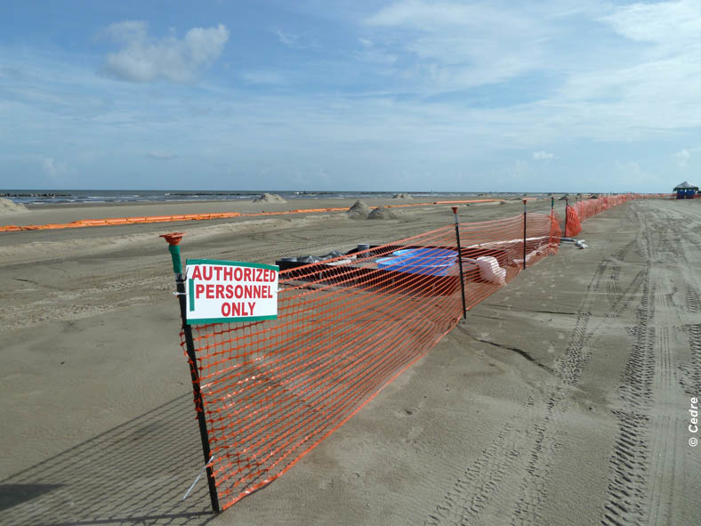

Implementation of a cleaning site on the shore ©CEDRE

Information resources
- The official site of the Deepwater Horizon Unified Command: Restore the Gulf
- NOAA (National Oceanic and Atmospheric Administration): Deepwater Horizon Incident, Gulf of Mexico
- Site des US Coast Guards
- Oil Spill Commission: National Commission on the BP Deepwater Horizon Oil Spill and Offshore Drilling
- BBC News: US evacuates oil rig after Gulf of Mexico leak
- Journal de l’environnement: La Louisiane menacée par la marée noire
- Le Monde: L'indemnisation des victimes pourrait prendre de cinq à dix ans
- LINFO.RE: Marée noire aux USA: projet de loi pour faire payer les compagnies pétrolières
- La Presse: L'état d'urgence décrété dans quatre États
- CNN: BP to try unprecedented engineering feat to stop oil spill
- Radio-Canada: L'immense caisson en route pour le puits
- Radio-Canada: BP opte pour la boue
- Le Parisien: Marée noire: Kevin Costner plaide pour sa machine à éliminer le pétrole
- L'avenir.net: BP va verser 500 millions de dollars pour étudier l’impact de la marée noire
- Mer et Marine: La marée noire touche les côtes américaines
- bfmtv.com: Des bancs de sable pour protéger la Louisiane de la marée noire

External links
Institutions
- National Ocenographic and Atmospheric Administration (NOAA): Data archive on the incident.
- Gulf British Petroleum: BP Press release.
- Restore The Gulf: The official website of the Gulf Coast Ecosystem Restoration Council.
- NOAA Fisheries Service: Organism regulating fishing bans.
- Gulf Spill Restoration: website maintained by NOAA on the behalf of the Deepwater Horizon Natural Resource Damage Assessment Trustees.
- U.S. Department Of Interior (DOI): Information on Deepwater Horizon oil spill.
- Clean Caribbean & Americas (CCA): Website for the 35 oil companies drilling in the Caribbean area.
- National Commission on the BP Deepwater Horizon Oil Spill and Offshore Drilling - Final Report: Final report of the National commission on the causes of the incident.
- NOAA Office and Response Restoration: OR&R and other NOAA Information on the Deepwater Horizon Oil Spill.

Media
- Oil Spill in the Gulf of Mexico: New York Times website.
- Website of the liveMSN MSN news channel for France.
- BP Oil Spill: Guardian website.
- Louisiane - Les première photos de la marée noire: Télégramme website.
- Dive into the Gulf’s toxic soup: ABC News website.

Monitoring of the pollution
- Google Earth: - Track the Oil Spill in the Gulf of Mexico .
-: NASA website.
-: Website for the University of Louisiana.
- United States Environment Protection Agency (EPA): Results from the monitoring carried out for air, water, sediments, and dispersants.
- United States Environment Protection Agency (EPA): Control of air quality on the shores of the Gulf of Mexico.
- National Centers for Coastal Ocean Science (NCCOS): Continuous monitoring programme for pollution in US coastal waters (ex.: Mussel Watch Program).
- BP Deepwater Horizon Oil Budget: What Happened to the Oil? : Estimation and fate of the amount of oil spilled.
- LPO: Incident and intervention sheet of Birdlife France.

Financial compensation
- BP Oil Spill settlement: Website for compensation claims.
- United States Environment Protection Agency (EPA): Cost covered by BP for EPA.

Synthetic articles
- Oil Rig Disasters: Website listing the main offshore oil rig incidents.
-: Incident news, regularly updated.

