Incident information sheet of SEA EMPRESS 1996

Table of Contents
The incident 2
Timeline of the events from 15 February to 7 March 1996 2
Behaviour of the oil and extent of the pollution 4
Response at sea 6
Involvement of the French Navy in response operations 8
Response on land 11
Intervention of Egmopol barges 12
Involvement of the European Community 14
Short-term impacts 16
Environmental monitoring 17
Fate of the spilled oil: 19
Financial compensation 19
Lessons learned from the pollution of the Sea Empress 21
23

The incident
On the night of 15 February 1996, the Liberian oil tanker Sea Empress, with 130,824 tonnes of Forties (light crude oil from the North Sea) as cargo, and journeying towards the Texaco refinery in Milford Haven, ran aground on the rocks at Saint Ann’s Head at the entrance to Milford Haven Bay (this location includes a number of refineries providing the UK with 25 % of its requirements in refined products).
This was the second grounding of an oil tanker in the span of 5 months after the Borga on 25 October 1995. But, unlike the Borga, the Sea Empress, despite having been built recently (1993), was a single hull vessel. According to experts, the reason for this incident lies in misjudgements of tidal currents and a communication breakdown between the pilot and the commanding officer.
This led to the spill of 72,500 tonnes of Forties crude and 360 tonnes of propulsion fuel.
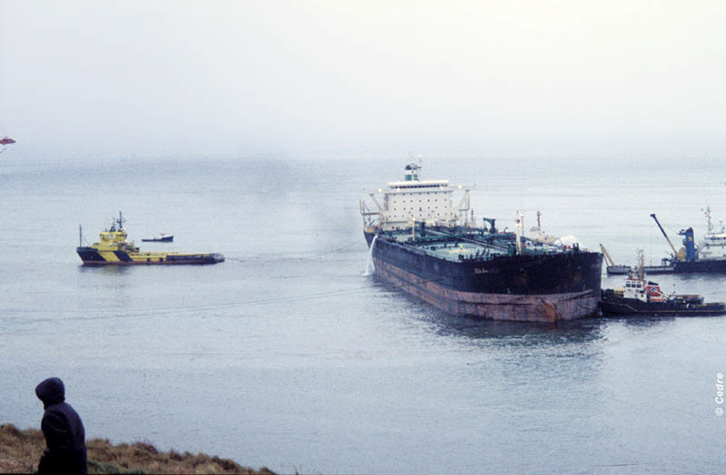

The Sea Empress aground at Milford Haven ©CEDRE

Timeline of the events from 15 February to 7 March 1996
As soon as the British coast guard was alerted, they implemented an emergency response plan. The MPCU (Marine Pollution Control Unit) sent out seven DC-3 aircrafts, equipped with spraying systems filled with dispersants, while the OSRL (Oil Spill Response Ltd) sent three trailers with shore response equipment, two storage barges, an Egmopol recovery barge, as well as a C130 Hercule aircraft equipped with the Adds Pack dispersant spraying system. However, the main objective was to stabilise the vessel to start lightering operations as soon as possible.
On 16 February, a first attempt at transferring the cargo was carried out by the Star Bergen, a 30,000 dwt oil tanker, with support from tugs from Liverpool and Ireland.
On 17 February, the weather worsened (40 knots of wind). The authorities decided to turn the vessel to face the wind and swell using seven tugs. Two towlines snapped and the vessel ran aground again at 18 h 05, close to her original position. A thousand tonnes of oil had already leaked since 15 February.
On 18 February, the Russian crew and the experts on site were airlifted from the wreck by a Sea King helicopter from the Royal Air Force at 5 h 30 due to the storm. The vessel was damaged by winds of westerly force 8 and waves of 4 to 5 metres. In the evening, the vessel was refloated thanks to the help from the Anglian Earl and Anglian Duke tugs and the De Yue, a powerful deep sea Chinese tug from Falmouth. She was held fast overnight by the Anglian Duke and the Anglian Earl. 7,000 tonnes of oil had already leaked since 17 February.
On 19 February at midday, the vessel ran aground near Channel Rock. She was refloated by six tugs by the end of the afternoon but grounded again by the stern, outside of the channel near St Ann’s Head. During these operations, the central and starboard tanks were damaged.
Of the 24 tanks on board, only 3 remained intact. The pumping room was flooded but the engine room remained dry, providing the vessel with full propulsion capacity.
On 20 February, a new refloating attempt was launched at high tide (highest of the month), with the help of nine tugs. The attempt failed and the situation worsened. 20,000 tonnes of oil had already leaked since 19 February.
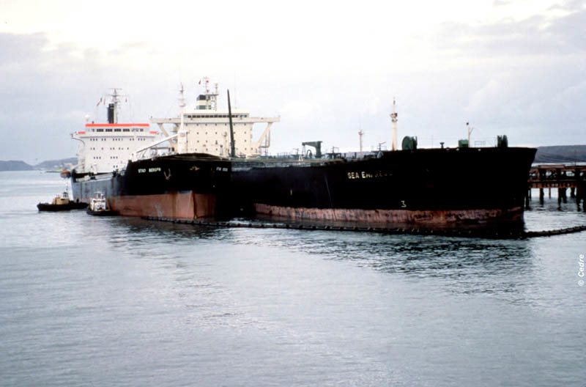

The Sea Empress during lightering operations at Herbrandston Jetty ©CEDRE

On 21 February, two more attempts were carried out at high tides, the first at 7 h 30 and the second at 21 h 00, with the help of 12 tugs, including those from the Dutch salvage company SMIT. The vessel was finally refloated at 22 h 00, after inert gas had been injected in the wing tanks. While these injections favoured the floatability of the oil tanker, they also caused major oil leaks from the damaged tanks, bringing the total amount spilled above 70,000 tonnes. Overnight, the oil tanker was towed to Herbrandston Jetty, a disused oil wharf of the former Esso refinery in Milford Haven Bay. After berthing, the vessel was circled with containment booms.
Once the hull had been assessed, pumping operations started on 23 February and lasted until 4 March after four transfer operations to the Star Bergen and the Onward Mariner, recovering a total of 58,200 tonnes of crude oil. The vessel was then towed to Belfast (Ireland) for repairs.

Behaviour of the oil and extent of the pollution

At sea, the pollution spread from the Bay of Carmarthen to Saint David’s Head, with sheen observed all the way to Lundy Island. At the beginning of March, the weather conditions favoured the catching of oil slicks on shore.
The oil spilled from perforations in the hull at the bottom of the tanks. The spill followed the tides and was most important during low tides. Therefore, pollution spread as a string of slicks, each series of slicks corresponding to a low tide.
Oil slicks were noted discontinuously on around 200 km of shoreline, with preferential accumulation areas such as Tenby Bay, the western side of Carmarthen Bay and Freshwater Bay; the inside of Milford Haven Bay was impacted on about 20 kilometres. Tar balls were also observed on the Irish coast, without confirmation that they came from the spill of the Sea Empress.
Monitoring showed that the oil had slightly adhered to the coast on exposed areas, from the entry to Milford Haven Bay to Carmarthen Bay. According to AEA (Atomic Energy Agency) Technology, mineral micro-particles might have mixed with the oil and reduced its adherability. This would have stabilised the droplets, preventing re-coalescence and favouring the dispersion in exposed locations.
A research programme carried out by AEA Technology helped confirm these hypotheses.
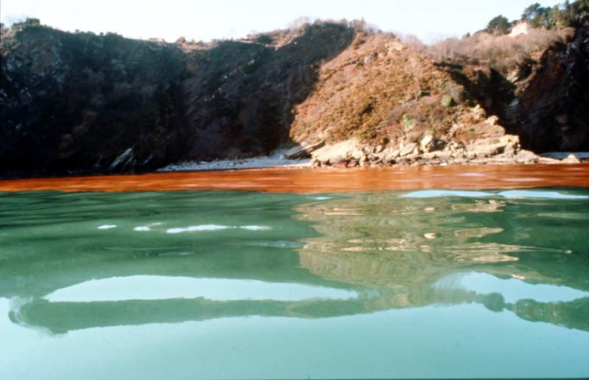

Emulsified oil in Tendy Bay ©CEDRE
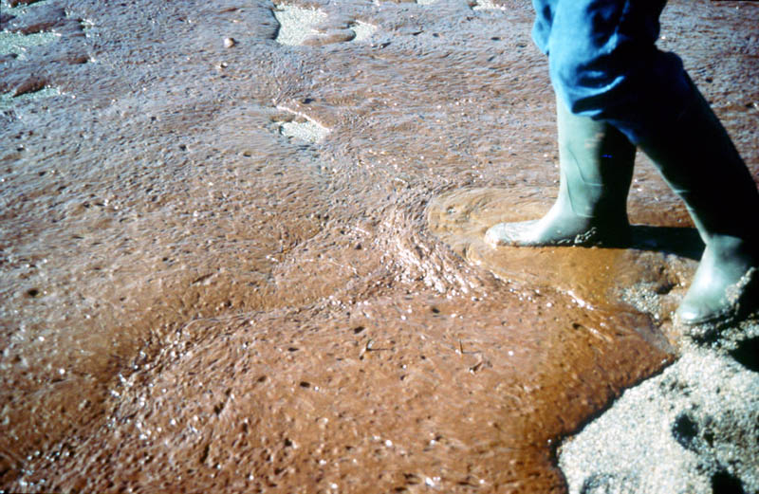

Emulsified oil on the beach in Swanvilake Bay ©CEDRE
Oil
Name: Forties
Density in kg/l (15 °C): 0,84
API density: 36,9
Pour point (°C): (- 12; + 3)
Viscosity (cSt): 9.6 at 10°C
7 at 20°C
Composition (vol %)
C1-C4: 2.74
C5 – 95° (petrol): 9.23
95°C – 149°C (naphta): 20.02
149 – 232°C (kerosene): 14.5
232 – 342°C (gas oil): 20.92
Sulphur (weight %): 0.32
Asphaltene (weight %): 0.2
Paraffins (weight %): 7
V/Ni (ppm/ppm): 3/2
Residue (vol % at 343°C): 40
- Viscosity (cSt at 50°C): 102
- Sulphur (weight %): 0.4
- V/Ni (ppm/ppm): 6/46
Observations
Evaporation of 30 to 40 % after 24 hours.
Emulsion: viscosity > 10,000 cSt in water after 5 days at 5°C.

Response at sea
Coordination
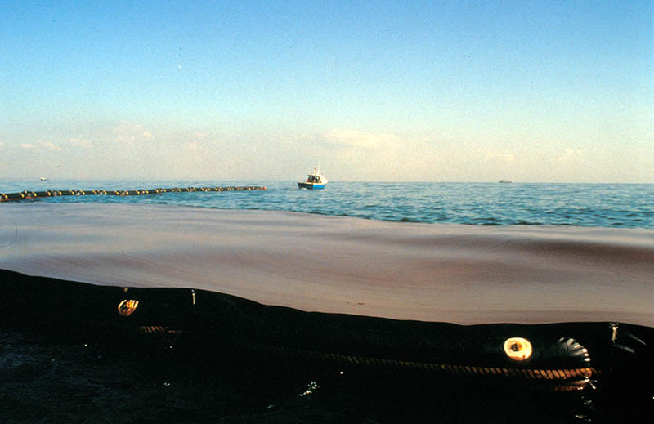
Oil confined at sea ©CEDRE
All response operations were coordinated by the JRC (Joint Response Centre) on land and the MPCU (Marine Pollution Control Unit) at sea. The JRC worked in collaboration with the Dyfed County Council and the Milford Haven Port Authority. A general manager was designated to oversee all operations. The OSRL (Oil Spill Response Limited) oil company was tasked with presetting its response equipment stockpile for response on land in Milford Haven. The JRC was piloted by a direction committee including local (Milford communities and port) and national authorities (MPCU) associated with other members, namely Texaco and ITOPF (International Tanker Owners Pollution Federation) representatives.
The command post of the JRC in Milford Haven was equipped with numerous pieces of equipment for communication and pre-filled maps which were constantly updated. Various independent units (nautical, technical, environmental, logistical, and press) were activated from there. In fact, up until the end of February, two distinct working groups could be observed. One focused on the issue of rescuing the vessel while the other focused on pollution response. All offers from third parties (manufacturers and providers) for services were analysed by the headquarters of the MPCU in Southampton.

Response at sea
Two strategies were implemented: chemical treatment from the air, and confinement and recovery from the sea. Seven DC-3 from the MPCU, managed by Atlantic Air Transport (capacity: 5 m³ of dispersant) and one Hercule C130 owned by the OSRL and equipped with an Adds Pack system ( capacity: 17 m³ of dispersant) sprayed dispersants from the first day. MCPU’s strategy consisted in treating the fresh oil in priority, as close to the wreck as possible.

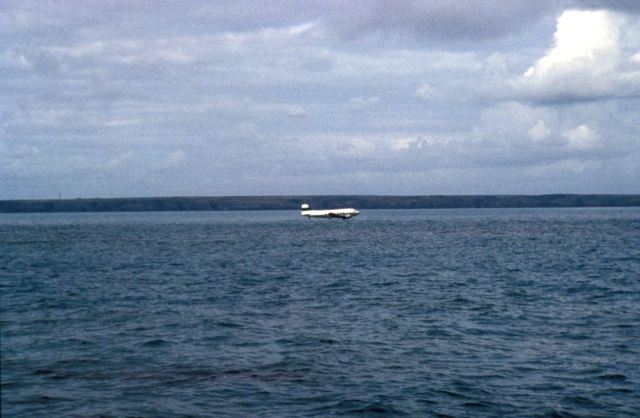
Spraying of dispersants from the air ©CEDRE

The treated areas were defined and monitored from teledetection and guide aircrafts from MPCU. Spraying operations from the air were carried out starting one nautical mile from the coast, outside the Bay, and during the ebb tide. These operations were stopped on 23 February as they were ineffective and most of the pollution had reached the coast. The dispersants seemed effective since sampling from AEA Technology showed that oil was dispersing in the water column (10 ppm right after spraying, 1 ppm an hour later).
In total, around 445 tonnes of dispersant were sprayed during these operations. The Dasic NS, Dasic LTSW and Finasol OSR52 were mostly used on fresh oil. Tests were carried out to disperse the propulsion fuel with Corexit 9 500. Aside from dispersant treatment, the MPCU also used all of its stores of Shell LA1834 demulsifiers, about 150 tonnes.
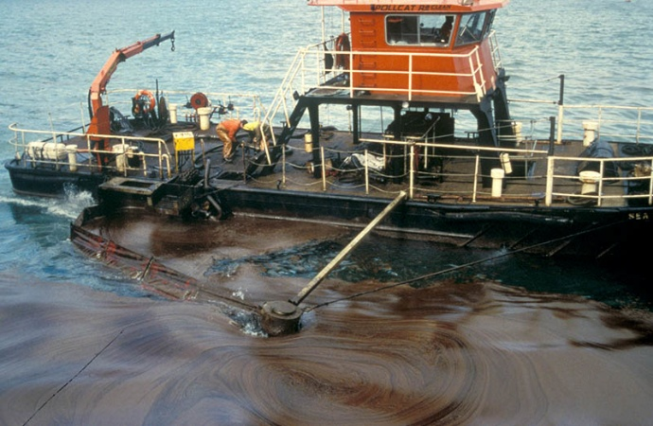

Le Sea Sweep ©CEDRE

Oil recovery on the coastline started on 15 February from the recovery boats Sea Mop et Sea Sweep (capacity: 40 m³ each), both equipped with an oleophilic rope skimmer.
On 20 February, the British boats Forth Explorer (capacity: 600 m³) equipped with a Foxtail system and the Self Supporter (capacity: 1,200 m³) equipped with the Marflex Arms system and a Sea Skimmer (Vikoma) arrived on site.
On 21 February, the French Navy sent two vessels: the Ailette equipped with a Transrec 250 system (400 m³ capacity) and the Élan, support boat to help with the deployment of the containment boom.
On 23 February, two more recovery boats, the Small Agt (capacity: 600 m³) and the Rijn Delta (capacity: 3,400 m³) were sent by the Netherlands.
Skimming on the coastline was carried out from two barges equipped with the Roskim skimming system (capacity: 100 m³) and from an Egmopol barge (capacity: 15 m³).

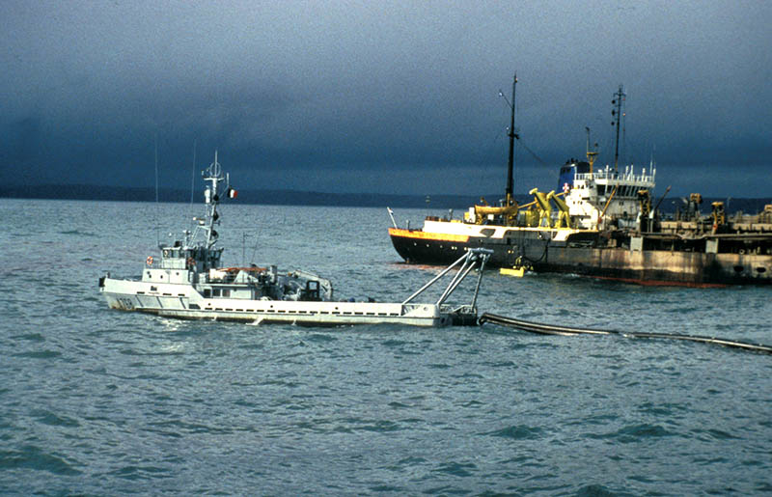
The Rijn and the Elan ©CEDRE

Small fishing boats were used to contain the oil in coastal waters and push it to the deep sea, where it was recovered. Later, on 4 March, two additional Egmopol barges were sent by France.
In total, 8,500 tonnes of emulsified oil were recovered at sea, containing about 4,000 tonnes of oil, representing an unprecedented international cooperation.

Involvement of the French Navy in response operations
On 20 February 1996, five days after the incident of the Sea Empress, the maritime prefect for the Atlantic suggested the use of French Navy response vessels to British authorities.
The British authorities immediately accepted the support from the French Navy. The supply Ailette and the regional support vessel Élan were sent, on the morning of 21 February 1996, with the necessary human and material resources for pollution response.
The vessels Ailette and Élan were equipped with suitable multi-task equipment for lightering, recovery, storage, and dispersant spraying operations. Aside from the vessel crews, CEPPOL, CEDRE, and the directorate of the military port of Brest had all sent support personnel.
The maritime prefect for the Atlantic tasked CEPPOL’s president, aboard the Ailette, with the coordination of response operations.
The schedules for the French vessels were organised on site by the MPCU (Marine Pollution Control Unit).
The British authorities used French equipment exclusively for the recovery of oil during eight consecutive days; 2,500 tonnes of emulsified product were recovered and stored on board of the Ailette.
Used for the first time in a real-life recovery situation, the TRANSREC 250 system showed great capacities.
The TRANSREC was deployed in a level 4 to 5 sea state; its performances were not impacted. Showing excellent manoeuvrability and operated by only one person, this piece of equipment was undoubtedly the best large-scale skimmer available in the world at that time.
The pumping operations were carried out on very viscous oil (20,000 cSt) emulsified to a mixture containing about 80 % water.
The Ailette and Élan vessels showed excellent manoeuvrability. Equipped with flexible propulsion systems, the deployment of booms on oil slicks was always easy and effective.
This mission proved that operational response quickly goes beyond the usual scope of pollution response training and is inscribed in a long-term approach requiring high awareness from the personnel in charge of equipment implementation.
The intervention of French vessels in pollution response operations in Wales was a great source for technical feedback. It opened doors for better international cooperation in the future contributing to the evolution of mindsets and strategies. In the context of cross-boundary environmental crises, European cooperation regarding pollution response will be implemented as such naturally, as often as necessary.
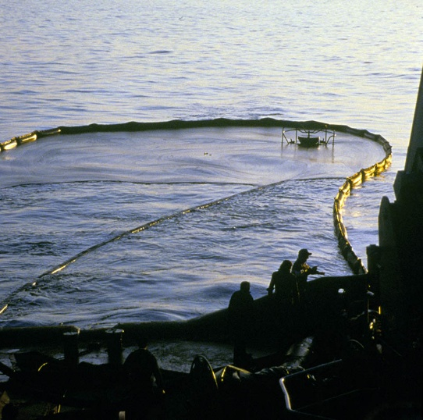

The TRANSEC recovering oil within a boom ©CEDRE

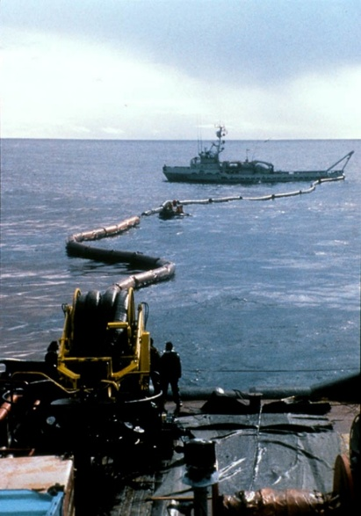
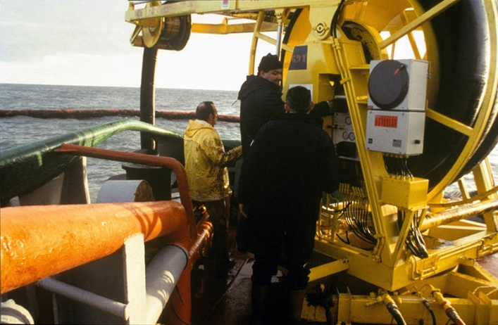

Response team on the deck of the Ailette ©CEDRE
Deployment of the TRANSEC ©CEDRE

Ailette:
- A TRANSEC 250 skimmer
- Two hydraulic generators
- A TK5 lightering pump (190 m³/h)
- Two dispersant spraying ramps
- 30 m³ of 3rd generation dispersants
- 110 m of ALL MARITIM booms
- 150 m of POLLUGUARD booms
- Two hull heating boilers
- Two power units
- 140 m of fluid transfer hoses
- A TRANSREC/TK5 pump adaptor
Élan:
- Two dispersant spraying ramps
- 12 m³ of 3rd generation dispersants
Observations:
- Evaporation of 30 to 40 % after 24 hours.
- Emulsion: viscosity > 10,000 cSt in water after 5 days at 5°C.

Response on land
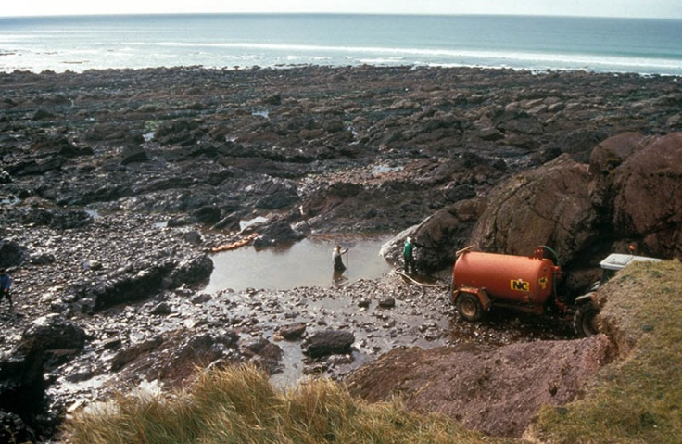
Oil on shore in West Freshwater Bay ©CEDRE

More than 500 people and 2,000 metres of booms, as well as a variety of equipment, were deployed on about thirty work sites on land. A protective layer of booms was installed on rivers and marshes which joined the Bay, as well as in front of ports (360 m of booms at the entrance of Pembroke port, 300 m in Milford Haven, 120 m in Neyland, 740 m to protect mashes and mudflats in Milford Haven Bay).
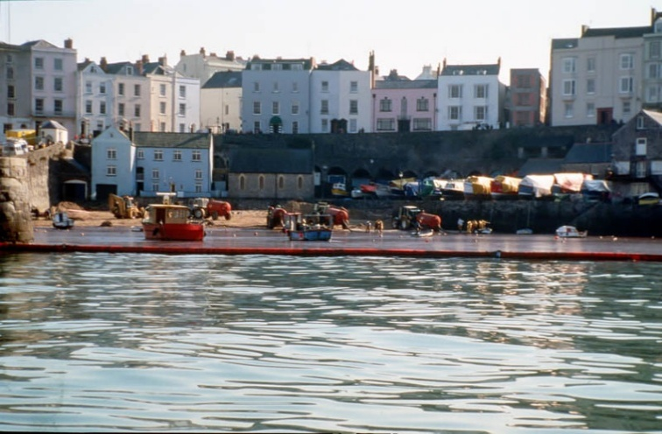
Cleaning operations in the port of Tendy ©CEDRE

Cleaning operations on beaches focused on the immediate vicinity of Milford Haven, namely in West Angle Bay, Angle Bay, and Blucks Pool. Traditional coastline cleaning resources were implemented. Collection was carried out using squeegies, shovels, bags, and barrels, as well as vacuum tanks. In areas where access was impossible for engines, collection was carried out manually and the waste was stored in bags.
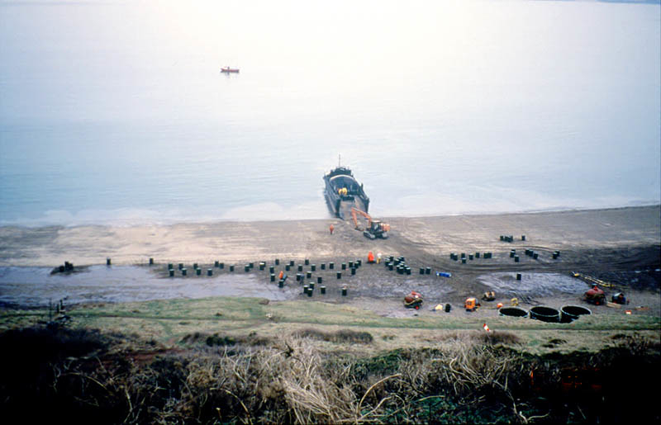
Storage worksite ©CEDRE

Most of the worksites benefited from OSRL resources (Desmi 250 recovery pumps, Vaculites, Komara skimmers) and national resources (vacuum tanks, manure tanks, public work engines, water-flushing).
About 14,000 m³ of liquid emulsified mixture and 3,000 m³ of soiled waste (including algae) were recovered, containing in total between 3,000 and 4,000 tonnes of oil.
Liquid waste was transported to the Texaco refinery in Pembroke for separation treatment.
Solid waste was redirected partly to the Texaco refinery for treatment by landfarming, and partly to multiple dumps for codisposal.

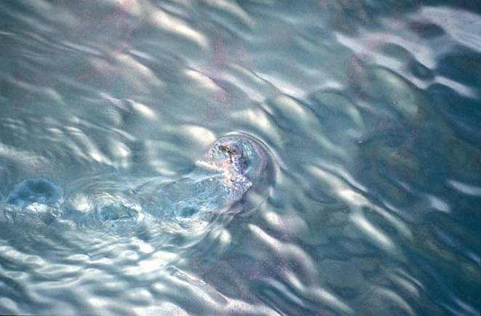
Grey seal in the middle of a slick ©CEDRE

Intervention of Egmopol barges
On 15 February 1996, the radio announced the grounding of the oil tanker Sea Empress in St Anne’s Head, on the coast of Wales, with 135,000 tonnes of Forties crude oil on board. The following morning, the Sycopol (French syndicate of manufacturers of pollution response equipment) transmitted a support proposal to ITOPF (International Tanker Owners Pollution Federation): the equipment available in France could be sent to the incident site with necessary human resources within 48 hours.
In parallel, the British authorities massively mobilised the available resources and the OSRL (Oil Spill Response Limited). The pollution response oil cooperative in Southampton sent a DAHSW 1041 Egmopol barge, as well as other equipment, on 16 February.
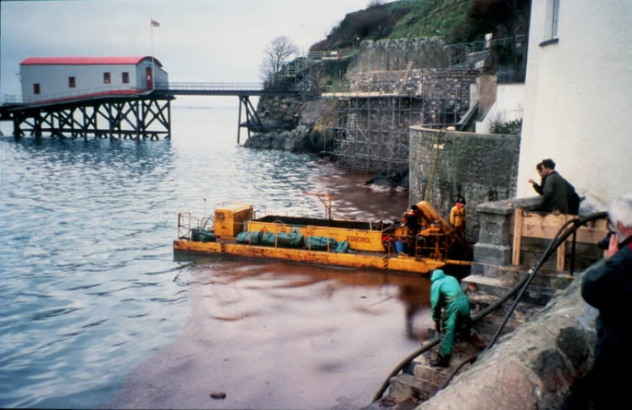

Egmopol barge in the port of Tendy ©CEDRE

The barge was used first on 19 February near the oil tanker, which in the meantime had been towed to a terminal located a few kilometres west of Milford Haven. A boom surrounded the vessel to contain the oil still leaking from the gaping holes in the hull. For the first four days, while the lightering operations of the vessel were being organised, the barge recovered around 100 m³ of oil, totalling 18 hours of work daily.
The following week, the slicks which had drifted into Milford estuary and port were pushed away and recovered by the barge. Thanks to its manoeuvrability, it was able to navigate to the edges of creeks and basins where the oil was thickest; 12 to 15 hours of works for two full loads of oil (30 m³) daily, unloaded in a barge transformed into a floating tank.
Following the success of the Egmopol barge, the MPCU (Marine Pollution Control Unit) contacted the Egmo company through its Scottish agent Alba International, to ask for the deployment of additional barges. On 1 March, two barges from the Polmar stockpile in Brest were sent to Wales through a hire purchase agreement. They were transported through Brittany and Wales in a special land convoy.
The French barges arrived on site on 3 March and were deployed, by Alba International personnel, to support the OSRL barge in Milford estuary and near Tenby, about 30 km from Milford Haven.
Oil recovery was carried out in the ports of Tenby and Milford at high tide; at low tide, it was carried out on the coastline. Three to four loads of oil were unloaded from each barge daily for treatment. By mid-March, the majority of the oil spilled had been collected. The barges were progressively stopped, cleaned, and stored.
Conclusion
The Egmopol barges are particularly effective for this type of pollution:
- the sheltered areas of Haven and the port of Tenby were an ideal setting for the use of the Egmolap;
- the low average thickness of the oil slicks justified the use of a baffle separator, which worked throughout skimming and allowed to unload a solution of 50 % oil minimum;
- some places were hard to reach by land or sea. The manoeuvrability and autonomy of the barges was therefore really useful.
Changes could nevertheless be made to improve comfort for the operators:
- provide lighting on water for work at night-time;
- include a waterproof storage compartment for personal belongings;
- Improve the grip on deck. The rubber grips were slippery when covered in oil.

Involvement of the European Community
Mobilisation of the community task force
The civil protection unit of the European Community was alerted by British authorities in the night of 15 February. The services from the Commission immediately established communication with the MPCU and the Community task force specialising in marine pollution was put on standby.
As the situation worsened, on 16 February, the necessary preparations began to send two experts of the task force on site. Their mission was to gather information and assist national authorities.
At the same time, the online data banks of the European Agency for the environment confirmed that a pollution by persisting oil in this area presented an elevated biological risk.
From 16 February, the services from the Commission shared daily information sheets, describing the evolution of the situation as well as the activities carried out by the Task Force experts, to member states and international organisations. Moreover, the EUROSPILL model, developed by the Commission, was used to predict the drift of slicks.
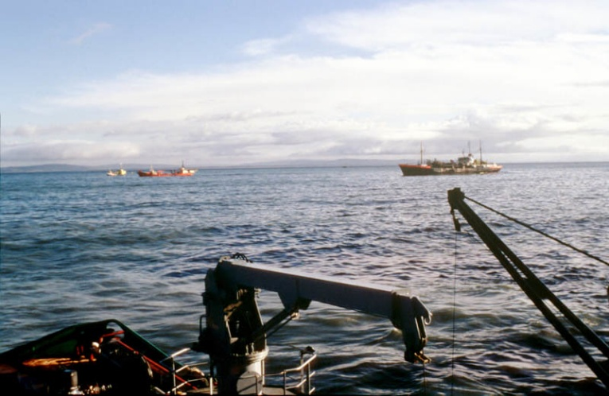

Vessel of the community task force ©CEDRE

The first team of experts sent on site included two CEDRE specialists, while an AEA (Atomic Energy Agency) Technology scientist was designated as coordinator for the European Community.
In collaboration with the MPCU, she was tasked with the coordination of the eventual presence of official observers from other member states, as a way to lighten the workload for the authorities and operational teams involved in the response operations.
Indeed, other member states, The Netherlands being the first, considered sending observers on site. On 18 February, two observers from the Netherlands and one From Ireland joined their French counterparts on site.
The information available at that time showed that the vessel was at high risk due to the state of her starboard and central tanks, as well as the disastrous weather.
On 20 February, the European experts at the Joint Response Centre discussed possible cooperation and international assistance. The offer from the French Navy to send two specialised vessels in the implementation of the TRANSREC recovery system was accepted by the MPCU.
After multiple days of difficult lightering operations, the Sea Empress was finally refloated and towed to the wharfs of Milford Haven on 21 February.
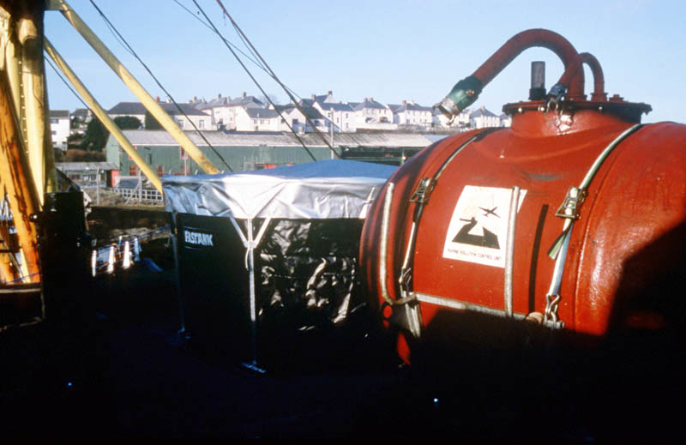

Storage equipment ©CEDRE

However, long and complicated recovery and cleaning operations were still needed.
On 21 February, three Swedish experts joined the group already formed on site, followed by two Italians and a Norwegian the next day. For their part, the Netherlands provided support through two vessels equipped with the “sweeping arm” recovery system, another example of the excellent cooperation between member states.
The two French observers and the two Dutch observers were also tasked with the roles of liaison officers between British authorities and their national counterparts.
As the situation improved, the European Community decided to put a stop to their actions starting on 4 March. The French and Dutch vessels left British national waters and the number of observers was reduced. The last observer from the Community Task Force left Milford Haven on 12 March 1996.

Financial support from the European Commission
Additionally, the authorities for the southern part of Wales, Cornwall and Devon, asked the European Commission for financial support to implement an environmental monitoring programme.
This kind of actions had already been implemented during the incidents of the Aegean Sea in 1992 and the Braer in 1993.
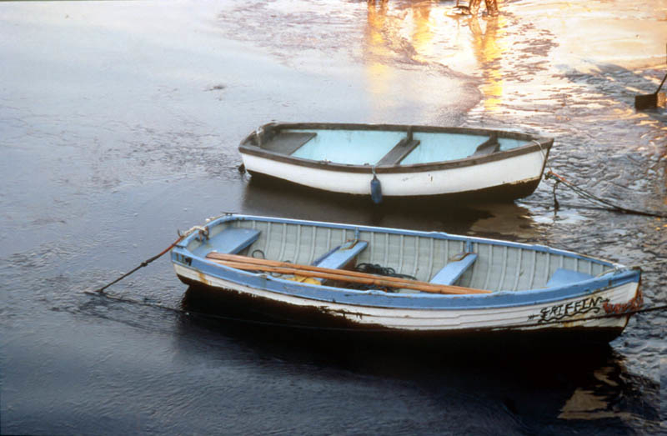

Oiled fishing boats ©CEDRE

Short-term impacts
Birds and mammals
The impact of the oil spill of the Sea Empress on birds and mammals remained relatively low compared to the amount of oil spilled. The data provided by the RSPCA (Royal Society for Prevention of Cruelty to Animals) showed that 2,961 dead birds and 6,900 oiled birds were reported.
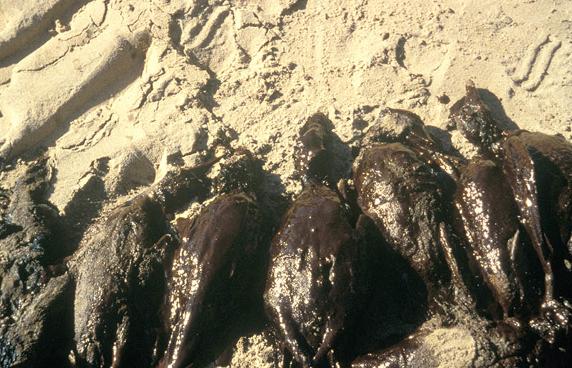

Oiled common scoters ©CEDRE
3,500 oiled birds were tended to, 75 % of them survived. The main species impacted, among the 25 in total, were common scoters (Melanitta nigra), common murres (Uria aalge), great cormorants (Phalacrocorax carbo) and razorbills (Alca torda).
The colonies on Skomer and Skokholm islands were only lightly impacted by the pollution. The ban on flyovers of the ornithological sanctuaries, established by the JRC, probably helped avoid scaring the nesting birds, which would have caused more deaths (move towards the oil slicks and oiling).
However, the WWF (World Wildlife Fund) considered that only 10 % of the dead birds were recovered, which indicates that the loss might be largely superior to the numbers provided.
260 seals were also oiled, without any death noted.

Fishing
From 1 March, a fishing ban was implemented from St David’s Head to Gower peninsula, in Swansea.
It was extended to the estuaries and rivers hosting migratory species such as salmon or sea trout. Indeed, the fraying season in river starts in April and line fishing season on 20 March. The fishing ban was lifted on 20 May.
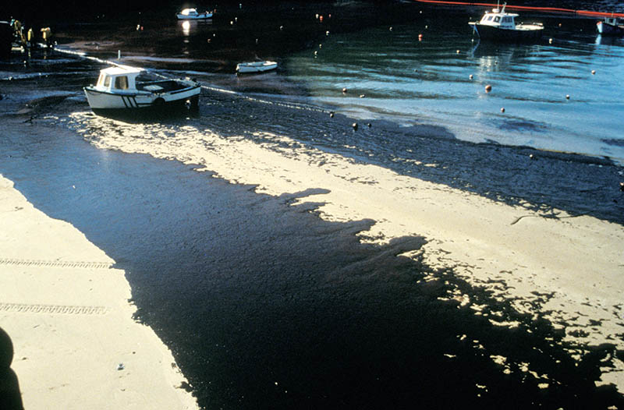

Grounded oil on the beach in Tendy ©CEDRE

Environmental monitoring
The south-western part of Wales counts around 35 SSSIs (Sites of Special Scientific Interest), a national park, one of the UK’s three maritime nature reserves, two European SACs (Special Areas of Conservation) and numerous other particular interest sites. Finally, the sport and recreational fishing activity as well as tourism are highly developed in the area.
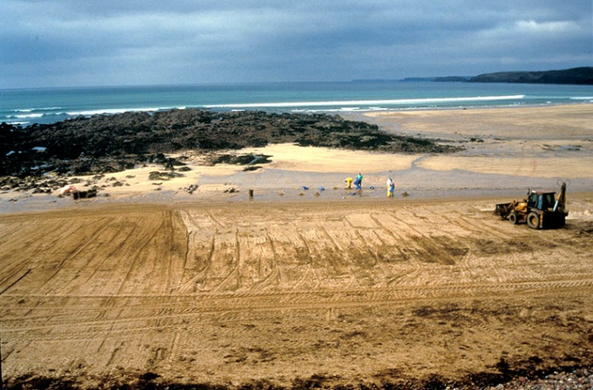

Cleaning worksite on a beach ©CEDRE

Milford Haven and the surrounding coastline were closely monitored these past 20 years, mainly to evaluate the impact of the increase in port and local oil industry activities on the marine fauna and flora. Scientists therefore have an excellent reference available to check for any change recorded after the pollution caused by the Sea Empress.
Directly after the incident, multiple teams started working on a study of the behaviour of the spilled oil (phenomena study for the concentration of naturally or chemically dispersed oils in the water column), as well as on an assessment of the damages caused by the pollution.
The need rapidly appeared to check if there was a lack in the data collected or if unwanted doubles were included due to a lack of coordination. These considerations led the Secretary of State for Wales to create the SEEEC (Sea Empress Environmental Evaluation Committee), presided by Professor Ron Edwards. The SEEEC was tasked with assessing the impact of the pollution caused by the Sea Empress and of the resulting cleaning and restoration operations on environmental resources in the polluted area, on fishing and agriculture, on infrastructure, on wildlife…
The SEEEC held its first meeting in early April 1996. Three focus groups were created: Sea, Land and coastline, fate of pollutants; each contained public and volunteer organisations, universities and technical companies operating in the area.
Following careful assessment by the groups, more than 80 study projects were considered as necessary for a good evaluation of the environmental impact of the incident. Today, most of these projects are ongoing, thanks to funding from multiple organisations and mainly thanks to the Welsh Office, the Ministry for the Environment, the Countryside Council for Wales, and the Ministry for Agriculture, Fisheries and Food.
These studies were compiled in reports during the spring or summer of 1997. The SEEEC published its final report in 1998.
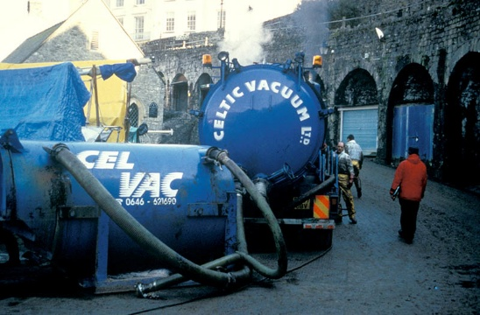

Pumping operations in the port of Tendy ©CEDRE

Fate of the spilled oil:
Mass balance of the pollution: 1996 evaluation
- 60,000 tonnes lightered and transferred to Texaco refinery;
- 73,000 tonnes spilled:
- 35 to 40 % would have evaporated (OSIS model),
- 10 to 20 % would have been naturally dispersed (OSIS model),
- 6 % was supposedly recovered at sea,
- 3 to 5 % was supposedly recovered on land,
- 13 % was supposedly dispersed,
- 20 % supposedly stayed trapped in the environment.

Financial compensation
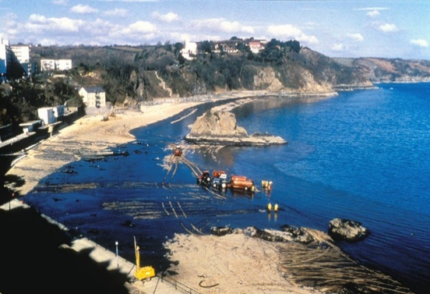
The United Kingdom was part of the 1969 Convention on civil liability and of the 1971 Convention on the creation of the funds (and of the 1992 Protocols to these Conventions, although they did not come into force yet).
A couple of days after the incident, the Skuld P&I Club (insurer for third party damages of the Sea Empress) and the IOPC Funds (The International Oil Pollution Compensation Funds) established a joint bureau for the management of compensation files. This bureau received claims regarding the cleaning costs and economical losses resulting from the pollution and transferred them to the Skuld P&I Club and IOPC Funds for complete examination.

Pumping on a Welsh beach ©CEDRE

By the end of June, the cleaning costs had reached, according to MPCU estimates:
- 3.1 million Francs for the use of aircrafts for dispersant spraying and monitoring;
- 2.55 million Francs for the purchase and transportation of
dispersants;
- 8.8 million Francs for beach cleaning.
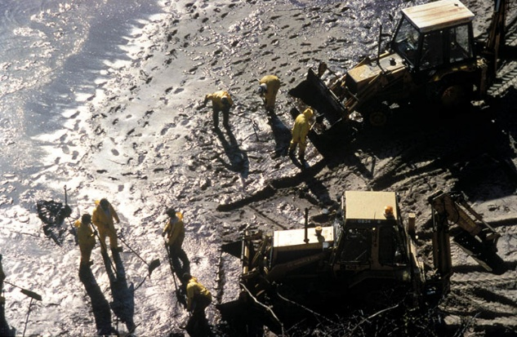

Cleaning worksite ©CEDRE
Due to the characteristics of the vessel and its insurance, the maximum amount for compensation, providing damage was justified, was of 425 million Francs, including 60 million from the insurer (Skuld P&I) and 365 million from the IOPC Funds.
In April, the Skuld had paid in advance 1.81 million Francs for 41 plaintiffs who had financial difficulties, fishermen, and tourism actors (hotels, nautical activity centres).
By mid-June, about 200 claims had already been filed to the joint bureau of Skuld and the IOPC Funds in Milford Haven. As the payment dates would probably span over years, it is still too soon to assess the full compensation amount. However, on 16 April, the executive committee for the IOPC Funds ordered the administrator to limit the payments to 75 % of the proven damages, as there was a risk for these compensations to surpass the maximum possible compensation limit.
A number of these claims have been closed since then. Particular attention was given to the claims linked to complicated situations, in particular from fishermen, with the aim of providing compensation quickly.

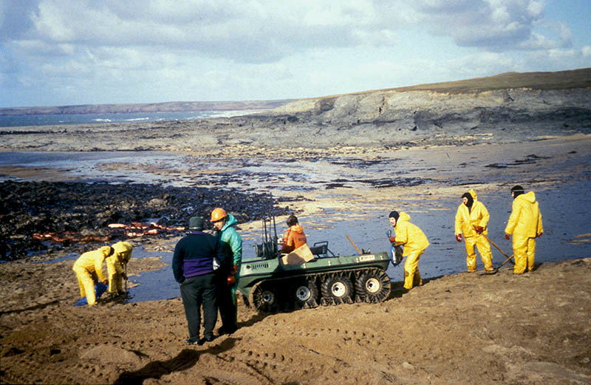

Manual cleaning on a Welsh beach ©CEDRE

Lessons learned from the pollution of the Sea Empress
Any incident of this magnitude naturally offers numerous lessons, and our British colleagues did not wait until the operations had concluded to implement mechanisms developed from these lessons.
Data flow
In theory, it should reflect and support the command scheme. Regarding the Sea Empress, the chain of command was quickly implemented. However, it seems that during maritime operations, data and decision transfer from the coast guard to Military staff was too slow and key information such as “people on board” was given different meanings. Due to the poor weather, the high number of ships in activity in the area and the diversity of public and private organisations involved in the on-site command centres, it was clear that slow and ambiguous communications could quickly lead to risks for the safety of the personnel, as well as bad situation management by Military Staff tasked with the general coordination of men and resources.
Two solutions were suggested to resolve these specific issues. First, implement “liaison officers” in each command centre where they would be needed, so they could transmit details and decisions to Military Staff without delay or misunderstanding. Second, more rigour was required in the redaction of transmissions, namely regarding IMO standards.
Media
The importance and complexity of the incident of the Sea Empress, as well as the fact that this incident happened three years after the pollution in the Shetlands severely handicapped the British authorities in their relations with the press and media.
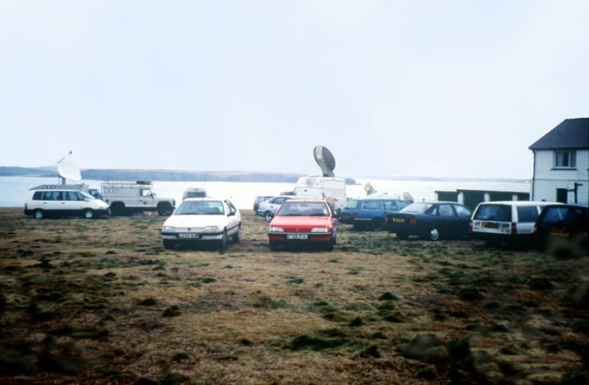

Press vehicles equipped with transmission antennas ©CEDRE
Strong lessons can be learned from this incident regarding communication management.
- Plans were undersized regarding actually competent personnel and the associated logistics.
- The press centre established at the beginning of the incident in Southampton to relieve the teams on site from media pressure was quickly forgotten by the press who tended to doubt the veracity of information given through too many intermediaries. It was therefore necessary to transfer the whole press team to Milford Haven, which created logistical issues.
- It was necessary to organise national contingency planning regarding communication with the media, in which the roles of each administration involved and local authorities was clearly stated. Moreover, this plan would integrate the help expected from the oil industry.
- Numerous general questions were asked by the media on the existing organisation, response techniques, dispersants and their use. These questions were not linked to the incident itself. The documents and information prepared for the Sea Empress will be used as a baseline for the redaction of information sheet which would be regularly updated and distributed to the press in the event of an incident.
- It would be useful, in the decision-making process, to have site images (video or televised) as soon as possible. The experiment showed that there were numerous shots of the response operations on land but very few shots of response operations at sea. Two solutions were considered: sign agreements with professionals (television or service providers) to immediately capture images and equip control centres and Military Staff to satellite access.
- It is necessary to seriously train managers and designated personnel to radio and TV interviews to reduce behaviour differences.
- The future contingency planning should be made so as to separate information meetings, for the professional press on one side, and for associations, various lobbies, local populations on the other.
- Finally, consideration will need to be given to the way the new information diffusion modes, namely the internet, should be controlled.
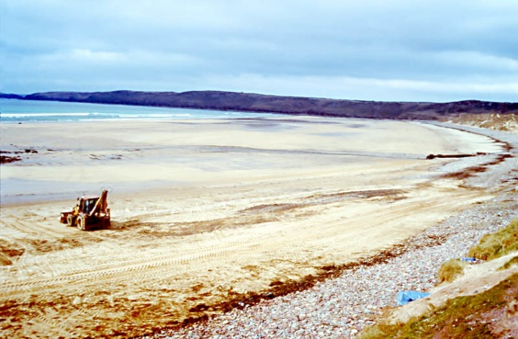

The Freshwater beach after cleaning operations ©CEDRE

Data collection
Numerous participants to maritime and land operations had already developed serious experience during previous pollutions. They were used to keeping a personal “logbook” where they mentioned all problems, possible solutions, decisions taken and conducted actions, which helped establish a general report after the events. However, this practice was not systemic, due to the high amount of personnel, origins, and different operational cultures. This resulted in wide inequality in the recording of information regarding this incident.
Consequently, British authorities worked to implement a standard recording approach for the various information regarding an incident using a Geographic Information System (GIS) as support. Consultations were held with local authorities, oil companies and ITOPF on the type of information to gather, as well as how to store and treat it.
Additional resources
In direct relations with the previous thematic, the MPCU conclusions showed an obvious need of non-specialised personnel in the Military Staff; they would be tasked with the reception, recording, diffusion of information, as well as the management of logistical issues in operation rooms. This kind of personnel was seemingly cruelly lacking during this incident.
Moreover, the British felt the need for a structure to answer the numerous ministerial, parliamentary or public interrogations. During the Sea Empress incident, the “Shipping Policy Directorate” was tasked with the organisation of such a structure. This directorate received 103 parliamentary questions. It wrote 405 ministerial letters and prepared 2,700 answer letters for individuals. The national British contingency planning will probably be revised to better reflect the cross-ministry role played by the “Shipping Policy Directorate” during major pollutions.
Documentary research
Each pollution event is new, while situational assessment necessitates access to reliable information as soon as possible.
The Sea Empress incident was no exception, in the rush to depart to Milford Haven , then during operations, CEDRE’s documentary department was asked to provide various residential and circumstantial data.

Upon alert, the following were needed as soon as possible:
The French marine maps from EPSHOM (Établissement principal du service hydrographique et océanographique de la Marine), located in Brest;
The English marine maps effectively completing the data from the EPSHOM maps through the Nautical Service (Le Havre);
The nautical instruction for England (south coast: last update available to CEDRE) which provides precious data on the geography, weather (wind), ocean (tides, currents, temperatures and sea state).
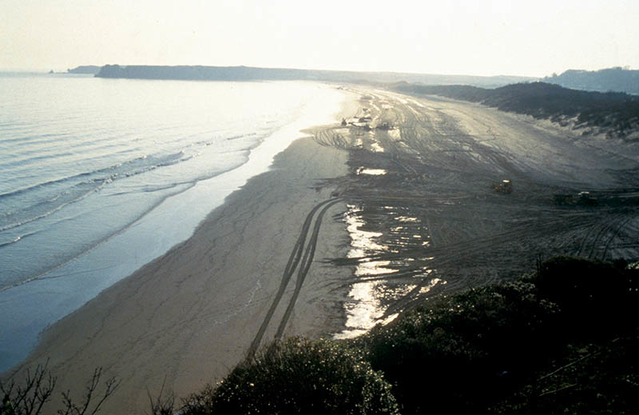

South Beach twenty days after the incident ©CEDRE

Once the first data was gathered, a query was made on the various datasets and banks available to the ESA-IRS server:
- AFP-EXTEL News, information agency providing the integral documentation on the most recent news regarding France and the United-Kingdom;
- Lloyd’s list, dataset providing the complete text of the daily newspaper of the same name, which specialises in navigation and vessels;

- ASFA (Aquatic Sciences and Fisheries Abstracts) which offered documentary references regarding the fragility of the coastline, fauna and flora, as well as fishing areas in this part of England. Some articles were not readily available and were ordered via fax. Part of them were sent to CEDRE this way;
- Pollution, database which was useful in completing the one from ASFA since it referenced articles on previous oil spills in Wales and on the effects of oil on fauna and flora.
After that, a systemic review was carried out to complete the available data, through:
- local daily French press: Ouest-France and Le Télégramme;
- local daily press: mainly the welsh paper the Western Mail (6-month subscription);
- specialised weekly press: the Oil Spill intelligence report, the Golob’s oil pollution bulletin (published every two years in the United States of America), the Marin, Cols Bleus…
Later on, additional information on the ecological impacts of this disaster were collected on the website of the Wales Swansea school of biological sciences (http://www.swan.ac.uk/empress/overview.htm).
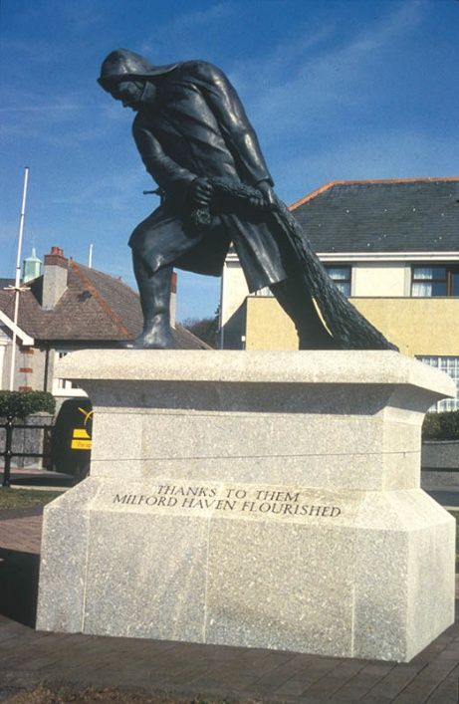

« Thanks to them Milford Haven flourished » ©CEDRE

