Incident information sheet of AMOCO CADIZ 1978

On 16 March 1978, following a failure in the steering system and lengthy negotiations with a German tug, after two failed towing attempts, the Libyan oil tanker Amoco Cadiz ran aground near Portsall, North Finistère, with its cargo of 223,000 tonnes of crude oil and 4,000 tonnes of bunker fuel oil. All of its cargo progressively leaked while the vessel broke on the rocks, polluting 360 km of coastline from Brest to Saint Brieuc.
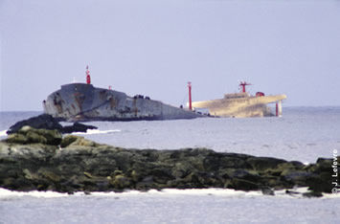

Wreck of the Amoco Cadiz near Portsall ©J. LE FEVRE

This was the largest oil spill caused by an oil tanker wreck in history. It encouraged the government to rework its POLMAR response plan, invest in response equipment (POLMAR stockpiles) and implement circulation schemes in the Channel.
The State and the polluted municipalities launched a long and complicated suit against the Amoco company in the United-States of America. After 14 years of legal proceedings, they obtained 1,257 million francs as compensation, about half of the amount claimed.
After the Amoco incident, the French authorities decided to create CEDRE. This tragic incident and its circumstances, pollution range and the shock it created are detailed in the following pages.

The incident
The morning of 16 March 1978, the Libyan oil tanker Amoco Cadiz, on its way from the Persian Gulf to Rotterdam with 223,000 tonnes of crude oil, was caught in a powerful storm and started drifting towards the coast of Brittany with a broken steering system. Negotiations with a German tug which came to its aid were tenuous. A first tow started at 13h30. It failed 3 hours later. Despite the efforts from both crews, the vessel wrecked on rock formations at 22h next to the port of Portsall. Multiple tanks broke. The first slicks quickly reached the shores. This was the start of the largest oil spill caused by an oil tanker wreck in history.
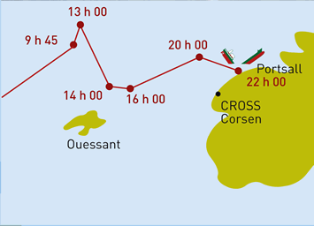

Drifting of the vessel

It took two weeks for the whole cargo to spill in the sea. Pushed by winds and currents, it polluted more than 300 km of one of the most beautiful and natural coastlines of Europe. Enraged, the French citizens launched desperate response operations against a disaster predicted so many times. The French media diffused apocalyptic images of an immense oil spill which shocked the nation.

A succession of oils spills!

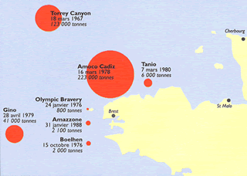

Oil slicks in Brittany before 1990
This record oil spill was not an isolated incident. The oil slick caused by the Torrey Canyon incident near Lands End (Cornwall), on 18 March 1967, was the first warning. Slicks drifted in the Channel and reached the Briton coastline, polluting from Morlaix to Plouescat in April, then in the Douarnenez and Audierne bays mid-May. On 24 January 1976, the stranding of the supertanker Olympic Bravery, thankfully empty, was the second warning with its spill of 1,200 tonnes of propulsion fuel. The third warning happened on 16 October 1976 with the sinking of the Boehlen off the Île de Sein, leaking 7,000 tonnes of its cargo of Venezuelan heavy fuel oil in the water.
And it did not end with the Amoco Cadiz. In 28 April 1979, the bulk carrier Gino sank near Ushant after an allision, bringing with it its cargo of carbon black, a thick product denser than water. On 7 March 1980, the Malagasy oil tanker Tanio broke in two during a storm off the Île de Batz and its rear end sank with 6,000 tonnes of heavy fuel on board. Finally, on 31 January 1988, a tank from the Italian oil tanker Amazzone lost more than 2,000 tonnes of crude oil during a storm off Penmarc’h. These oil slicks encouraged the Briton population to act for change and hold the polluters accountable.

Response during the first days
The 14 km of pollution response booms from the equipment stockpile (POLMAR) of the Equipment department were insufficient against the hundreds of thousands of tonnes of “chocolate mousse” (name given to the oil-water emulsion) arriving on the coastlines. Shovels, buckets, floating pumps, manure tanks, dump trucks, tank cars… Anything that could collect and transport became a response equipment to recover and evacuate the pollutant towards temporary storage dumps.
In a matter of days, 7,000 volunteers and as many military personnel got to work to clean the most polluted rocks, beaches and trees. In a couple of weeks, they recovered more than fifteen thousand tonnes of oil and three times as much soiled algae, sand and debris.
Clinics were deployed for oiled birds in the Finistère and Côtes d’Armor departments. Sadly, only one in twenty birds could be saved.
Some grey seal cadavers were recovered on beaches in the Côtes d’Armor department. Mostly, along 300 km of coastlines, the flora and fauna from the foreshore died in huge numbers, trapped under the oil and removed alongside it by high pressure hoses and cleaning shovels.
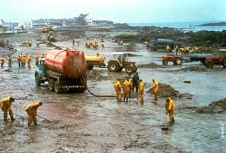

Manure tanks used to store the oil pumped on the shoreline ©NOAA

An organised response
After the desperate response of the first days, an organised system started to form. At sea, the use of dispersants and sinking agents, as well as the winds, limited the range of the slicks to the Bréhat island.
Beach clean-up was organised in two parts: first pumping of the liquid oil, then recovering the oiled waste. In total, more than a hundred thousand tonnes of mousse and oiled waste were collected. Most of the solid waste was neutralised using lime treatment.
The 1,300 fishermen from the maritime sectors of Brest, Morlaix, and Paimpol were the first affected by the oil spill: fishing was banned from the day of the incident to the end of April. Oyster farms were also greatly impacted: oysters from the abers and the Morlaix bay, oiled or unfit for consumption, were destroyed. Fishers on foot could do nothing but witness the damage on high tide days. The tourism sector risked having its season completely ruined. The maritime administration implemented financial support for the impacted fishermen and oyster farmers.

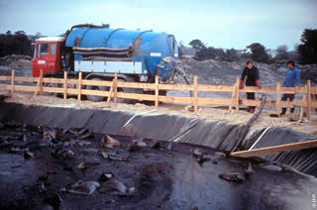

Waste storage ©IFP

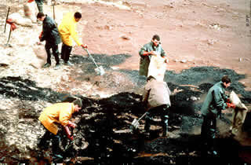

Manual collection ©IFP

One year later, a first assessment
In Autumn of 1978, most of the pollution was cleaned off the coast, aside from the remaining waste storage still being evacuated. While the winter storms finished the cleaning operations started by volunteers, public bodies, scientists, ecologists, sea and tourism professionals started assessing the impacts of the tragedy.
In November 1979, a conference revealed the first damage assessment: between 19,000 and 37,000 dead birds, 6,400 tonnes of oysters destroyed, harvests of oysters and shellfish greatly impacted, thousands of fishermen banned from fishing for weeks or even months, and a greatly impacted tourism sector. But, even more important than the short-term damage, the future worried the experts. How could nature find balance again? An important set of measures were implemented to avoid another disaster such as this one. At the same time, the state and municipalities, determined to hold the polluter accountable, started judiciary proceedings against the Amoco company in the United-States, an action that will last 14 years.

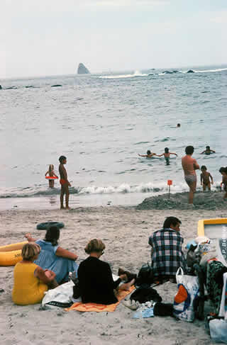
The beach of Portsall, one year after the incident, looked like any other beach: filled with sandcastles and swimmers ©P. BELLIER

Scientists and economists at work
To have a better understanding of what was to come, and to precisely quantify the damages for the legal proceedings, precise data was required regarding ecology, economy, and sociology.
State funding, a fund from the Amoco company, and donations allowed for the creation of a wide study programme mobilising a hundred of French and American scientists and economists.
Teams from the Université de Bretagne Occidentale, the economy lab from INRA (the National Institute of Agricultural Research) in Rennes, the CNEXO ocean research centre for Brittany (now called Ifremer), The marine station in Roscoff, the ornithological station of Birdlife France on Île Grande, as well as private study institutes each within their expertise sector, assessed the damages to private properties and public infrastructures, economic losses, and the impact on natures. They planned to assess their results after five and ten years.
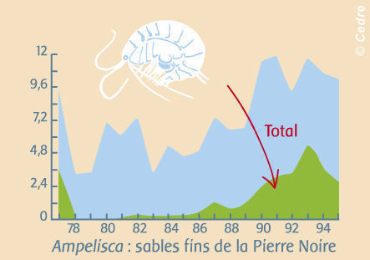

Evolution of the fine sand populations of Pierre Noire, Morlaix river : temporary loss of sand hoppers (Ampelisca) ©: Dauvin J.-C. Mar. Poll. Bull., 1998, 36(9) 669-676)

The State and municipalities added up the sums from response operations, funding for fishermen, the fish farming sector, and the tourism industry. Three teams of economists worked to quantify the commercial losses and the negative impact on public image. Twenty-five ecological studies were carried out on various areas and shore types of the oiled shoreline. These studies revealed a multitude of issues, namely:
- How to differentiate spending for the maintenance of roads due to pollution response from usual maintenance spending?
- Which bases to use to quantify losses from fishing on foot, which was not the subject of any prior analysis?
- Is it possible to accelerate the natural degradation of oil in marshes from which it is impossible to remove? Or to accelerate the natural re-population of the environments?
- Could fishes, crustaceans, and shellfish spawned right after the disaster develop?
It was not easy and required a lot of time and money. Results from these observations and assessments varied a lot from one activity to another, one species to another, one place to another. Experts from Amoco redid the measures and calculations, contested the results, and forced the other teams to reopen files that were considered clear.
Every number and conclusion was subject to a confrontation between experts that lawyers tried to destabilise. Mathematical models used by the French were questioned by the teams of Amoco, which included a Nobel prize recipient for Economy. The judges ruled: Amoco will compensate 50 to 60% of the cleaning costs and financial help given to the State and fishermen/fish farmers for the duration of the bans on fishing, 25 to 30% of the maintenance costs for the roads and for the replacement of municipalities’ damaged public works equipment, 15 to 20% of the economic damage at medium and long term claimed for fishing, fish farming and tourism.

Medium term impact
In the years to follow, the scientists estimated that the oil spill killed, by trapping or toxicity, around 260,000 tonnes of marine animals. They highlighted a progressive colonisation by opportunistic species, which were resistant to oil, in the most affected areas between 1978 and 1979.
They were then joined by tolerant species, which represented more than 75% of the population in 1982-1983. Finally, species that were sensitive and very sensitive to oil repopulated and reached their usual presence levels in 1984-1985. In total, 6 to 7 years were necessary for an approximative return to prior conditions.
Economists struggled to understand the situation. Damage to fishing was hard to quantify due to the constant evolution of fishing techniques and resources. Tourism stats showed very strong variations from one year to another, which masked the actual effect of the oil spill. Experts threw hypotheses and mathematical formulas at each other while the American judge admitted he had difficulties understanding the reality of things. The situation would have benefited from a global damage assessment, well organised with harmonised, internationally validated working methods. But how when such an event never happened before?
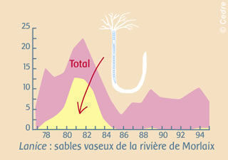

Evolution of sand mashes in the Morlaix river: temporary colonisation by opportunistic polychaeta (Lanice) © Dauvin J.-C. Mar. Poll. Bull., 2000, 40(6), 528-536)

Fourteen years of legal proceedings
The Amoco Transport company, charterer of the Amoco Cadiz, only contracted a light insurance regarding damage from incidental pollution.
Aware that legal proceedings in France would not force Amoco Transport to give financial compensation, the State, municipalities and individuals impacted by the pollution decided to sue the parent company, the Amoco International Oil Company, a subsidiary of the powerful Standard Oil of Indiana. This led them to New York, then Chicago for a large-scale judicial fight. On one side: the French State, two departments, ninety municipalities, thousands of individuals grouped in associations, dozens of scientists and some lawyers. On the other side: the Amoco group with its hundreds of lawyers and experts, including a Nobel laureate for economy.
It took 14 years, with a first ruling in 1988 then a correction in 1992, for Amoco to finally pay compensation. The State and municipalities had to pay considerable amounts and sent half a million documents with the tribunal. They originally filed a claim for 1 billion francs. The ruling from 1990 gave them 340 million, which equalled 695 million with late fees. The rectification of 1992, re-evaluating the damages and the interest rate, got the compensation up to 1.25 billion francs.
The hope for compensation regarding the ecological damage was short-lived when faced with the harshness of the judicial combat. The question was raised again, 30 years later, during the trial regarding the Erika.

Never again!
While the experts were adding up the damages and the lawyers were getting ready for a trial in the United-States, the French Government took a collection of measures to reduce the risks of incidents and equip itself with better response equipment.
Everyone agreed: this type of incident could not happen again. A new POLMAR response plan was implemented. A navigational rail was created off Ushant, forcing vessels carrying hazardous cargo to be at least 50 km from the coastline. A powerful offshore tug was permanently stationed on this rail for support. Watchmen and on-call officers were present 24/7 at the maritime prefecture for the Atlantic, and at the CROSS in Pointe du Corsen.
This was however not enough to stop the pollutions from the Gino, Tanio, Amazzone, Erika, or Prestige incidents. Still, the risk was predicted and a specialised technical centre was created to ensure permanent technical monitoring and operational advice in case of emergencies: these are the missions of CEDRE, located in Brest and available 24/7 in the event of a pollution.
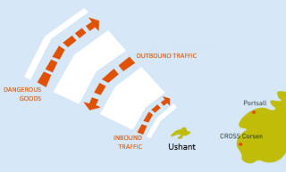

Traffic Separation Scheme in Ushant

Books by the children of Portsall
For the 20 years of the oil spill, the children from Portsall elementary and middle-school wrote, with their teacher and a professional author, two beautiful novels.
The first pages are available in pdf format:
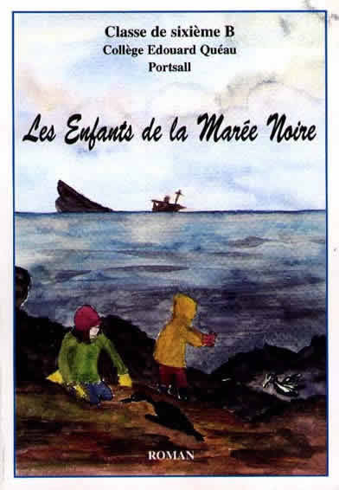

Children of the oil spill
https://wwz.cedre.fr/content/download/5380/file/roman1.pdf
https://wwz.cedre.fr/content/download/5381/file/roman2.pdf
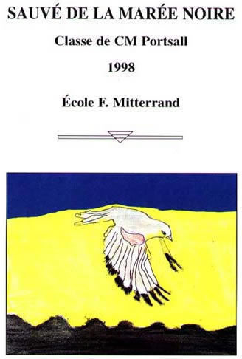

Saved from the oil spill

Twenty, and thirty years later
in 1998, twenty years after the disaster, the last ecological monitoring work still showed traces of imbalance in some benthic populations in the floors of the most affected bays. But for the tourism and fishing industries, as well as for every other economic activity, the oil spill of the Amoco Cadiz is now a distant memory. The scientists feared the long-term effects on some species, regarding the risk of cancer on surviving animals, a reduction of their reproduction abilities, as well as more fragile generations born after the pollution. Scientific studies showed none of the above. A wide variety of complex effects, complicated to interpret, was observed. It was difficult to know if these effects were solely due to the pollution from the Amoco Cadiz when other factors came into play year after year on the economic and ecological equilibriums of the coastline.
Other oil spills happened, the tourism sector changed, the methods and priorities of the fishing industry evolved, new spills or urban and agricultural pollutants made their appearance in catchment areas and on the coastline. The wreck became a refuge for fishes and crustaceans, and an exploration spot for experienced divers. Tourists coming to visit Portsall get their picture taken in front of the vessel’s anchor, erected as a symbol on the port. The oil spill of the Amoco Cadiz is now part of history.
In 2008, thirty years after the tragedy, the memory of the Amoco Cadiz was replaced with more recent events such as the Erika and the Prestige. The stakeholders of the Amoco incident left the professional sector one after the other. Their voices became progressively quieter. Still, what they had to say remains relevant today.
Which is why CEDRE published "Amoco Cadiz, mémoires vives", a collection of discussions with the most important of these “retired responders” of the Amoco.

